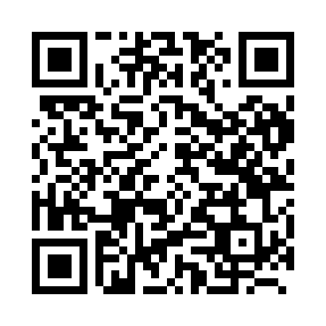
Prayer times for Eliksem, Belgium
Wed 1 May 2024 - Fri 31 May 2024
High Latitude Method: Angle Based Rule
Prayer Calculation Method: Muslim World League
Asar Calculation Method: Shafi

Date | Day | Fajr | Sunrise | Dhuhr | Asr | Maghrib | Isha
1 | Wed | 3:49 | 6:13 | 1:37 | 5:39 | 9:02 | 11:16
2 | Thu | 3:45 | 6:11 | 1:37 | 5:40 | 9:03 | 11:19
3 | Fri | 3:42 | 6:10 | 1:37 | 5:41 | 9:05 | 11:22
4 | Sat | 3:38 | 6:08 | 1:37 | 5:41 | 9:06 | 11:25
5 | Sun | 3:35 | 6:06 | 1:37 | 5:42 | 9:08 | 11:28
6 | Mon | 3:31 | 6:04 | 1:37 | 5:42 | 9:09 | 11:31
7 | Tue | 3:28 | 6:03 | 1:36 | 5:43 | 9:11 | 11:34
8 | Wed | 3:24 | 6:01 | 1:36 | 5:44 | 9:13 | 11:37
9 | Thu | 3:22 | 6:00 | 1:36 | 5:44 | 9:14 | 11:40
10 | Fri | 3:21 | 5:58 | 1:36 | 5:45 | 9:16 | 11:44
11 | Sat | 3:21 | 5:56 | 1:36 | 5:45 | 9:17 | 11:44
12 | Sun | 3:20 | 5:55 | 1:36 | 5:46 | 9:19 | 11:45
13 | Mon | 3:19 | 5:53 | 1:36 | 5:47 | 9:20 | 11:45
14 | Tue | 3:19 | 5:52 | 1:36 | 5:47 | 9:22 | 11:46
15 | Wed | 3:18 | 5:50 | 1:36 | 5:48 | 9:23 | 11:47
16 | Thu | 3:18 | 5:49 | 1:36 | 5:48 | 9:24 | 11:47
17 | Fri | 3:17 | 5:48 | 1:36 | 5:49 | 9:26 | 11:48
18 | Sat | 3:17 | 5:46 | 1:36 | 5:49 | 9:27 | 11:49
19 | Sun | 3:16 | 5:45 | 1:36 | 5:50 | 9:29 | 11:49
20 | Mon | 3:16 | 5:44 | 1:37 | 5:50 | 9:30 | 11:50
21 | Tue | 3:15 | 5:42 | 1:37 | 5:51 | 9:31 | 11:51
22 | Wed | 3:15 | 5:41 | 1:37 | 5:52 | 9:33 | 11:51
23 | Thu | 3:14 | 5:40 | 1:37 | 5:52 | 9:34 | 11:52
24 | Fri | 3:14 | 5:39 | 1:37 | 5:53 | 9:35 | 11:52
25 | Sat | 3:14 | 5:38 | 1:37 | 5:53 | 9:37 | 11:53
26 | Sun | 3:13 | 5:37 | 1:37 | 5:54 | 9:38 | 11:54
27 | Mon | 3:13 | 5:36 | 1:37 | 5:54 | 9:39 | 11:54
28 | Tue | 3:13 | 5:35 | 1:37 | 5:55 | 9:40 | 11:55
29 | Wed | 3:12 | 5:34 | 1:37 | 5:55 | 9:41 | 11:55
30 | Thu | 3:12 | 5:33 | 1:38 | 5:55 | 9:42 | 11:56
31 | Fri | 3:12 | 5:32 | 1:38 | 5:56 | 9:43 | 11:56
Prayer times provided by https://www.salahtimes.com

