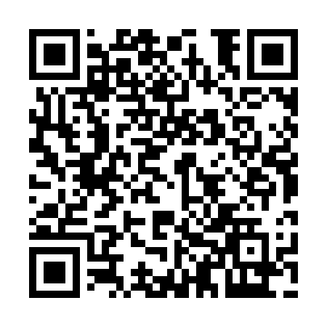
Prayer times for De Normanville, Quebec, Canada
Mon 1 Apr 2024 - Tue 30 Apr 2024
High Latitude Method: Angle Based Rule
Prayer Calculation Method: Islamic Society of North America
Asar Calculation Method: Hanafi

Date | Day | Fajr | Sunrise | Dhuhr | Asr | Maghrib | Isha
1 | Mon | 5:03 | 6:29 | 12:54 | 5:23 | 7:20 | 8:46
2 | Tue | 5:01 | 6:27 | 12:54 | 5:24 | 7:21 | 8:47
3 | Wed | 4:59 | 6:25 | 12:53 | 5:25 | 7:23 | 8:49
4 | Thu | 4:57 | 6:23 | 12:53 | 5:26 | 7:24 | 8:50
5 | Fri | 4:54 | 6:21 | 12:53 | 5:27 | 7:25 | 8:52
6 | Sat | 4:52 | 6:19 | 12:52 | 5:28 | 7:27 | 8:54
7 | Sun | 4:50 | 6:17 | 12:52 | 5:29 | 7:28 | 8:55
8 | Mon | 4:48 | 6:15 | 12:52 | 5:30 | 7:29 | 8:57
9 | Tue | 4:46 | 6:14 | 12:52 | 5:31 | 7:31 | 8:59
10 | Wed | 4:43 | 6:12 | 12:51 | 5:31 | 7:32 | 9:00
11 | Thu | 4:41 | 6:10 | 12:51 | 5:32 | 7:33 | 9:02
12 | Fri | 4:39 | 6:08 | 12:51 | 5:33 | 7:35 | 9:04
13 | Sat | 4:37 | 6:06 | 12:51 | 5:34 | 7:36 | 9:06
14 | Sun | 4:35 | 6:04 | 12:50 | 5:35 | 7:37 | 9:07
15 | Mon | 4:32 | 6:02 | 12:50 | 5:36 | 7:39 | 9:09
16 | Tue | 4:30 | 6:01 | 12:50 | 5:37 | 7:40 | 9:11
17 | Wed | 4:28 | 5:59 | 12:50 | 5:38 | 7:41 | 9:13
18 | Thu | 4:26 | 5:57 | 12:49 | 5:38 | 7:43 | 9:14
19 | Fri | 4:23 | 5:55 | 12:49 | 5:39 | 7:44 | 9:16
20 | Sat | 4:21 | 5:54 | 12:49 | 5:40 | 7:45 | 9:18
21 | Sun | 4:19 | 5:52 | 12:49 | 5:41 | 7:47 | 9:20
22 | Mon | 4:17 | 5:50 | 12:49 | 5:42 | 7:48 | 9:22
23 | Tue | 4:15 | 5:48 | 12:48 | 5:43 | 7:49 | 9:23
24 | Wed | 4:12 | 5:47 | 12:48 | 5:43 | 7:51 | 9:25
25 | Thu | 4:10 | 5:45 | 12:48 | 5:44 | 7:52 | 9:27
26 | Fri | 4:08 | 5:43 | 12:48 | 5:45 | 7:53 | 9:29
27 | Sat | 4:06 | 5:42 | 12:48 | 5:46 | 7:55 | 9:31
28 | Sun | 4:04 | 5:40 | 12:48 | 5:47 | 7:56 | 9:33
29 | Mon | 4:02 | 5:39 | 12:48 | 5:48 | 7:57 | 9:35
30 | Tue | 4:00 | 5:37 | 12:47 | 5:48 | 7:59 | 9:36
Prayer times provided by https://www.salahtimes.com

