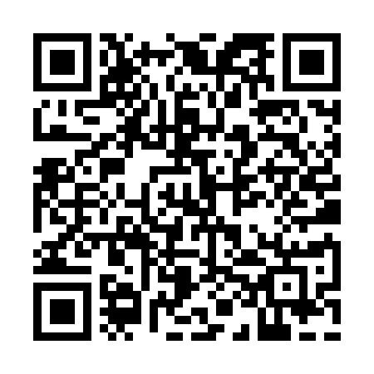
Prayer times for Cottonwood Village, Utah, USA
Mon 1 Apr 2024 - Tue 30 Apr 2024
High Latitude Method: Angle Based Rule
Prayer Calculation Method: Islamic Society of North America
Asar Calculation Method: Shafi

Date | Day | Fajr | Sunrise | Dhuhr | Asr | Maghrib | Isha
1 | Mon | 5:53 | 7:10 | 1:31 | 5:06 | 7:53 | 9:10
2 | Tue | 5:51 | 7:08 | 1:31 | 5:06 | 7:54 | 9:11
3 | Wed | 5:49 | 7:07 | 1:30 | 5:07 | 7:55 | 9:12
4 | Thu | 5:48 | 7:05 | 1:30 | 5:07 | 7:56 | 9:14
5 | Fri | 5:46 | 7:03 | 1:30 | 5:08 | 7:57 | 9:15
6 | Sat | 5:44 | 7:02 | 1:30 | 5:08 | 7:58 | 9:16
7 | Sun | 5:42 | 7:00 | 1:29 | 5:08 | 7:59 | 9:17
8 | Mon | 5:40 | 6:59 | 1:29 | 5:09 | 8:00 | 9:19
9 | Tue | 5:38 | 6:57 | 1:29 | 5:09 | 8:01 | 9:20
10 | Wed | 5:37 | 6:55 | 1:28 | 5:09 | 8:02 | 9:21
11 | Thu | 5:35 | 6:54 | 1:28 | 5:10 | 8:03 | 9:22
12 | Fri | 5:33 | 6:52 | 1:28 | 5:10 | 8:04 | 9:24
13 | Sat | 5:31 | 6:51 | 1:28 | 5:10 | 8:05 | 9:25
14 | Sun | 5:29 | 6:49 | 1:27 | 5:11 | 8:06 | 9:26
15 | Mon | 5:28 | 6:48 | 1:27 | 5:11 | 8:07 | 9:28
16 | Tue | 5:26 | 6:46 | 1:27 | 5:11 | 8:08 | 9:29
17 | Wed | 5:24 | 6:45 | 1:27 | 5:12 | 8:09 | 9:30
18 | Thu | 5:22 | 6:43 | 1:27 | 5:12 | 8:10 | 9:32
19 | Fri | 5:21 | 6:42 | 1:26 | 5:12 | 8:12 | 9:33
20 | Sat | 5:19 | 6:40 | 1:26 | 5:13 | 8:13 | 9:34
21 | Sun | 5:17 | 6:39 | 1:26 | 5:13 | 8:14 | 9:36
22 | Mon | 5:15 | 6:37 | 1:26 | 5:13 | 8:15 | 9:37
23 | Tue | 5:14 | 6:36 | 1:26 | 5:14 | 8:16 | 9:38
24 | Wed | 5:12 | 6:35 | 1:25 | 5:14 | 8:17 | 9:40
25 | Thu | 5:10 | 6:33 | 1:25 | 5:14 | 8:18 | 9:41
26 | Fri | 5:08 | 6:32 | 1:25 | 5:14 | 8:19 | 9:42
27 | Sat | 5:07 | 6:30 | 1:25 | 5:15 | 8:20 | 9:44
28 | Sun | 5:05 | 6:29 | 1:25 | 5:15 | 8:21 | 9:45
29 | Mon | 5:03 | 6:28 | 1:25 | 5:15 | 8:22 | 9:47
30 | Tue | 5:02 | 6:27 | 1:24 | 5:16 | 8:23 | 9:48
Prayer times provided by https://www.salahtimes.com

