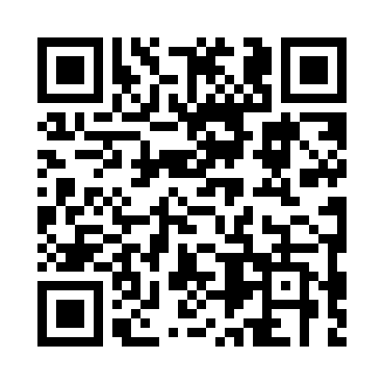
Prayer times for Erbisoeul, Belgium
Mon 1 Apr 2024 - Tue 30 Apr 2024
High Latitude Method: Angle Based Rule
Prayer Calculation Method: Muslim World League
Asar Calculation Method: Shafi

Date | Day | Fajr | Sunrise | Dhuhr | Asr | Maghrib | Isha
1 | Mon | 5:24 | 7:20 | 1:48 | 5:22 | 8:17 | 10:06
2 | Tue | 5:21 | 7:18 | 1:48 | 5:23 | 8:19 | 10:08
3 | Wed | 5:19 | 7:15 | 1:48 | 5:23 | 8:21 | 10:10
4 | Thu | 5:16 | 7:13 | 1:47 | 5:24 | 8:22 | 10:12
5 | Fri | 5:13 | 7:11 | 1:47 | 5:25 | 8:24 | 10:14
6 | Sat | 5:10 | 7:09 | 1:47 | 5:26 | 8:25 | 10:17
7 | Sun | 5:08 | 7:07 | 1:46 | 5:27 | 8:27 | 10:19
8 | Mon | 5:05 | 7:05 | 1:46 | 5:27 | 8:29 | 10:21
9 | Tue | 5:02 | 7:02 | 1:46 | 5:28 | 8:30 | 10:23
10 | Wed | 4:59 | 7:00 | 1:46 | 5:29 | 8:32 | 10:25
11 | Thu | 4:56 | 6:58 | 1:45 | 5:30 | 8:33 | 10:28
12 | Fri | 4:53 | 6:56 | 1:45 | 5:30 | 8:35 | 10:30
13 | Sat | 4:51 | 6:54 | 1:45 | 5:31 | 8:37 | 10:32
14 | Sun | 4:48 | 6:52 | 1:45 | 5:32 | 8:38 | 10:35
15 | Mon | 4:45 | 6:50 | 1:44 | 5:33 | 8:40 | 10:37
16 | Tue | 4:42 | 6:48 | 1:44 | 5:33 | 8:41 | 10:39
17 | Wed | 4:39 | 6:46 | 1:44 | 5:34 | 8:43 | 10:42
18 | Thu | 4:36 | 6:44 | 1:44 | 5:35 | 8:45 | 10:44
19 | Fri | 4:33 | 6:42 | 1:43 | 5:36 | 8:46 | 10:47
20 | Sat | 4:30 | 6:40 | 1:43 | 5:36 | 8:48 | 10:49
21 | Sun | 4:27 | 6:38 | 1:43 | 5:37 | 8:49 | 10:52
22 | Mon | 4:24 | 6:36 | 1:43 | 5:38 | 8:51 | 10:54
23 | Tue | 4:21 | 6:34 | 1:43 | 5:38 | 8:53 | 10:57
24 | Wed | 4:18 | 6:32 | 1:42 | 5:39 | 8:54 | 10:59
25 | Thu | 4:15 | 6:30 | 1:42 | 5:40 | 8:56 | 11:02
26 | Fri | 4:11 | 6:28 | 1:42 | 5:40 | 8:57 | 11:04
27 | Sat | 4:08 | 6:26 | 1:42 | 5:41 | 8:59 | 11:07
28 | Sun | 4:05 | 6:24 | 1:42 | 5:42 | 9:01 | 11:10
29 | Mon | 4:02 | 6:22 | 1:42 | 5:42 | 9:02 | 11:13
30 | Tue | 3:59 | 6:20 | 1:42 | 5:43 | 9:04 | 11:15
Prayer times provided by https://www.salahtimes.com

