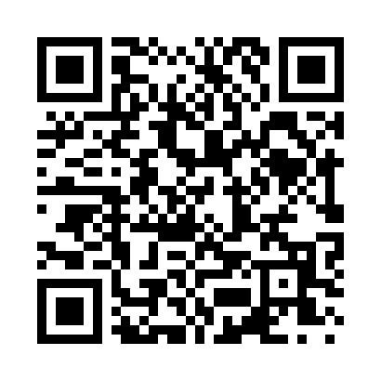
Prayer times for Schuyler Lake, New York, USA
Mon 1 Jul 2024 - Wed 31 Jul 2024
High Latitude Method: Angle Based Rule
Prayer Calculation Method: Islamic Society of North America
Asar Calculation Method: Shafi

Date | Day | Fajr | Sunrise | Dhuhr | Asr | Maghrib | Isha
1 | Mon | 3:40 | 5:26 | 1:04 | 5:08 | 8:42 | 10:28
2 | Tue | 3:41 | 5:26 | 1:04 | 5:08 | 8:42 | 10:27
3 | Wed | 3:42 | 5:27 | 1:05 | 5:09 | 8:42 | 10:27
4 | Thu | 3:43 | 5:28 | 1:05 | 5:09 | 8:41 | 10:26
5 | Fri | 3:44 | 5:28 | 1:05 | 5:09 | 8:41 | 10:26
6 | Sat | 3:44 | 5:29 | 1:05 | 5:09 | 8:41 | 10:25
7 | Sun | 3:45 | 5:30 | 1:05 | 5:09 | 8:40 | 10:24
8 | Mon | 3:47 | 5:30 | 1:05 | 5:09 | 8:40 | 10:24
9 | Tue | 3:48 | 5:31 | 1:05 | 5:09 | 8:40 | 10:23
10 | Wed | 3:49 | 5:32 | 1:06 | 5:09 | 8:39 | 10:22
11 | Thu | 3:50 | 5:33 | 1:06 | 5:09 | 8:39 | 10:21
12 | Fri | 3:51 | 5:33 | 1:06 | 5:09 | 8:38 | 10:20
13 | Sat | 3:52 | 5:34 | 1:06 | 5:09 | 8:37 | 10:19
14 | Sun | 3:53 | 5:35 | 1:06 | 5:09 | 8:37 | 10:18
15 | Mon | 3:55 | 5:36 | 1:06 | 5:08 | 8:36 | 10:17
16 | Tue | 3:56 | 5:37 | 1:06 | 5:08 | 8:35 | 10:16
17 | Wed | 3:57 | 5:38 | 1:06 | 5:08 | 8:35 | 10:15
18 | Thu | 3:59 | 5:38 | 1:06 | 5:08 | 8:34 | 10:14
19 | Fri | 4:00 | 5:39 | 1:06 | 5:08 | 8:33 | 10:12
20 | Sat | 4:01 | 5:40 | 1:07 | 5:08 | 8:32 | 10:11
21 | Sun | 4:03 | 5:41 | 1:07 | 5:07 | 8:31 | 10:10
22 | Mon | 4:04 | 5:42 | 1:07 | 5:07 | 8:31 | 10:08
23 | Tue | 4:06 | 5:43 | 1:07 | 5:07 | 8:30 | 10:07
24 | Wed | 4:07 | 5:44 | 1:07 | 5:07 | 8:29 | 10:06
25 | Thu | 4:08 | 5:45 | 1:07 | 5:06 | 8:28 | 10:04
26 | Fri | 4:10 | 5:46 | 1:07 | 5:06 | 8:27 | 10:03
27 | Sat | 4:11 | 5:47 | 1:07 | 5:06 | 8:26 | 10:01
28 | Sun | 4:13 | 5:48 | 1:07 | 5:05 | 8:25 | 10:00
29 | Mon | 4:14 | 5:49 | 1:07 | 5:05 | 8:24 | 9:58
30 | Tue | 4:16 | 5:50 | 1:07 | 5:05 | 8:22 | 9:56
31 | Wed | 4:17 | 5:51 | 1:06 | 5:04 | 8:21 | 9:55
Prayer times provided by https://www.salahtimes.com

