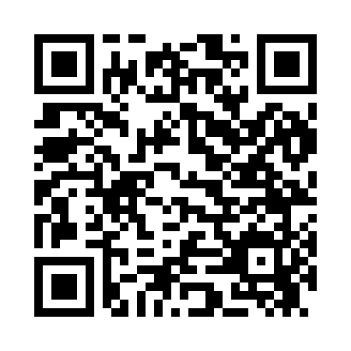
Prayer times for Chickamaw Beach, Minnesota, USA
Mon 1 Jul 2024 - Wed 31 Jul 2024
High Latitude Method: Angle Based Rule
Prayer Calculation Method: Islamic Society of North America
Asar Calculation Method: Shafi

Date | Day | Fajr | Sunrise | Dhuhr | Asr | Maghrib | Isha
1 | Mon | 3:25 | 5:28 | 1:22 | 5:34 | 9:15 | 11:18
2 | Tue | 3:25 | 5:29 | 1:22 | 5:34 | 9:15 | 11:18
3 | Wed | 3:26 | 5:29 | 1:22 | 5:34 | 9:14 | 11:18
4 | Thu | 3:26 | 5:30 | 1:22 | 5:34 | 9:14 | 11:17
5 | Fri | 3:28 | 5:31 | 1:22 | 5:34 | 9:14 | 11:16
6 | Sat | 3:29 | 5:31 | 1:22 | 5:34 | 9:13 | 11:15
7 | Sun | 3:30 | 5:32 | 1:23 | 5:34 | 9:13 | 11:14
8 | Mon | 3:32 | 5:33 | 1:23 | 5:34 | 9:12 | 11:13
9 | Tue | 3:33 | 5:34 | 1:23 | 5:34 | 9:12 | 11:12
10 | Wed | 3:34 | 5:35 | 1:23 | 5:34 | 9:11 | 11:11
11 | Thu | 3:36 | 5:36 | 1:23 | 5:34 | 9:10 | 11:10
12 | Fri | 3:38 | 5:37 | 1:23 | 5:34 | 9:10 | 11:08
13 | Sat | 3:39 | 5:37 | 1:23 | 5:33 | 9:09 | 11:07
14 | Sun | 3:41 | 5:38 | 1:24 | 5:33 | 9:08 | 11:05
15 | Mon | 3:42 | 5:39 | 1:24 | 5:33 | 9:07 | 11:04
16 | Tue | 3:44 | 5:40 | 1:24 | 5:33 | 9:07 | 11:02
17 | Wed | 3:46 | 5:41 | 1:24 | 5:33 | 9:06 | 11:01
18 | Thu | 3:48 | 5:42 | 1:24 | 5:32 | 9:05 | 10:59
19 | Fri | 3:49 | 5:44 | 1:24 | 5:32 | 9:04 | 10:58
20 | Sat | 3:51 | 5:45 | 1:24 | 5:32 | 9:03 | 10:56
21 | Sun | 3:53 | 5:46 | 1:24 | 5:32 | 9:02 | 10:54
22 | Mon | 3:55 | 5:47 | 1:24 | 5:31 | 9:01 | 10:52
23 | Tue | 3:57 | 5:48 | 1:24 | 5:31 | 9:00 | 10:51
24 | Wed | 3:58 | 5:49 | 1:24 | 5:30 | 8:59 | 10:49
25 | Thu | 4:00 | 5:50 | 1:24 | 5:30 | 8:57 | 10:47
26 | Fri | 4:02 | 5:51 | 1:24 | 5:30 | 8:56 | 10:45
27 | Sat | 4:04 | 5:53 | 1:24 | 5:29 | 8:55 | 10:43
28 | Sun | 4:06 | 5:54 | 1:24 | 5:29 | 8:54 | 10:41
29 | Mon | 4:08 | 5:55 | 1:24 | 5:28 | 8:52 | 10:39
30 | Tue | 4:10 | 5:56 | 1:24 | 5:28 | 8:51 | 10:37
31 | Wed | 4:12 | 5:57 | 1:24 | 5:27 | 8:50 | 10:35
Prayer times provided by https://www.salahtimes.com

