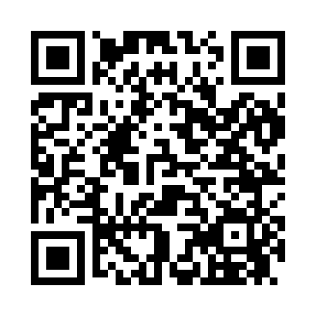
Prayer times for Cotton Center, California, USA
Wed 1 May 2024 - Fri 31 May 2024
High Latitude Method: Angle Based Rule
Prayer Calculation Method: Islamic Society of North America
Asar Calculation Method: Shafi

Date | Day | Fajr | Sunrise | Dhuhr | Asr | Maghrib | Isha
1 | Wed | 4:45 | 6:03 | 12:54 | 4:39 | 7:44 | 9:03
2 | Thu | 4:44 | 6:02 | 12:53 | 4:39 | 7:45 | 9:04
3 | Fri | 4:43 | 6:01 | 12:53 | 4:39 | 7:46 | 9:05
4 | Sat | 4:41 | 6:00 | 12:53 | 4:40 | 7:47 | 9:06
5 | Sun | 4:40 | 5:59 | 12:53 | 4:40 | 7:48 | 9:07
6 | Mon | 4:39 | 5:58 | 12:53 | 4:40 | 7:49 | 9:08
7 | Tue | 4:37 | 5:57 | 12:53 | 4:40 | 7:50 | 9:09
8 | Wed | 4:36 | 5:56 | 12:53 | 4:40 | 7:50 | 9:11
9 | Thu | 4:35 | 5:55 | 12:53 | 4:40 | 7:51 | 9:12
10 | Fri | 4:34 | 5:54 | 12:53 | 4:40 | 7:52 | 9:13
11 | Sat | 4:33 | 5:53 | 12:53 | 4:41 | 7:53 | 9:14
12 | Sun | 4:31 | 5:53 | 12:53 | 4:41 | 7:54 | 9:15
13 | Mon | 4:30 | 5:52 | 12:53 | 4:41 | 7:55 | 9:16
14 | Tue | 4:29 | 5:51 | 12:53 | 4:41 | 7:55 | 9:17
15 | Wed | 4:28 | 5:50 | 12:53 | 4:41 | 7:56 | 9:18
16 | Thu | 4:27 | 5:49 | 12:53 | 4:41 | 7:57 | 9:19
17 | Fri | 4:26 | 5:49 | 12:53 | 4:41 | 7:58 | 9:20
18 | Sat | 4:25 | 5:48 | 12:53 | 4:42 | 7:59 | 9:21
19 | Sun | 4:24 | 5:47 | 12:53 | 4:42 | 7:59 | 9:23
20 | Mon | 4:23 | 5:47 | 12:53 | 4:42 | 8:00 | 9:24
21 | Tue | 4:22 | 5:46 | 12:53 | 4:42 | 8:01 | 9:25
22 | Wed | 4:22 | 5:45 | 12:53 | 4:42 | 8:02 | 9:26
23 | Thu | 4:21 | 5:45 | 12:53 | 4:42 | 8:02 | 9:27
24 | Fri | 4:20 | 5:44 | 12:54 | 4:43 | 8:03 | 9:28
25 | Sat | 4:19 | 5:44 | 12:54 | 4:43 | 8:04 | 9:29
26 | Sun | 4:18 | 5:43 | 12:54 | 4:43 | 8:05 | 9:30
27 | Mon | 4:18 | 5:43 | 12:54 | 4:43 | 8:05 | 9:30
28 | Tue | 4:17 | 5:42 | 12:54 | 4:43 | 8:06 | 9:31
29 | Wed | 4:16 | 5:42 | 12:54 | 4:44 | 8:07 | 9:32
30 | Thu | 4:16 | 5:41 | 12:54 | 4:44 | 8:07 | 9:33
31 | Fri | 4:15 | 5:41 | 12:54 | 4:44 | 8:08 | 9:34
Prayer times provided by https://www.salahtimes.com

