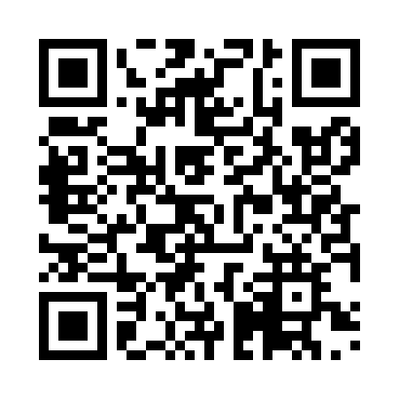
Prayer times for Matsushima, Japan
Wed 1 May 2024 - Fri 31 May 2024
High Latitude Method: None
Prayer Calculation Method: Muslim World League
Asar Calculation Method: Shafi

Date | Day | Fajr | Sunrise | Dhuhr | Asr | Maghrib | Isha
1 | Wed | 2:59 | 4:39 | 11:33 | 3:21 | 6:27 | 8:01
2 | Thu | 2:57 | 4:38 | 11:33 | 3:21 | 6:28 | 8:02
3 | Fri | 2:56 | 4:37 | 11:33 | 3:22 | 6:29 | 8:04
4 | Sat | 2:54 | 4:35 | 11:32 | 3:22 | 6:30 | 8:05
5 | Sun | 2:53 | 4:34 | 11:32 | 3:22 | 6:31 | 8:06
6 | Mon | 2:51 | 4:33 | 11:32 | 3:22 | 6:32 | 8:08
7 | Tue | 2:50 | 4:32 | 11:32 | 3:22 | 6:33 | 8:09
8 | Wed | 2:48 | 4:31 | 11:32 | 3:23 | 6:34 | 8:10
9 | Thu | 2:47 | 4:30 | 11:32 | 3:23 | 6:35 | 8:12
10 | Fri | 2:45 | 4:29 | 11:32 | 3:23 | 6:36 | 8:13
11 | Sat | 2:44 | 4:28 | 11:32 | 3:23 | 6:36 | 8:14
12 | Sun | 2:42 | 4:27 | 11:32 | 3:23 | 6:37 | 8:16
13 | Mon | 2:41 | 4:26 | 11:32 | 3:24 | 6:38 | 8:17
14 | Tue | 2:40 | 4:25 | 11:32 | 3:24 | 6:39 | 8:18
15 | Wed | 2:38 | 4:24 | 11:32 | 3:24 | 6:40 | 8:19
16 | Thu | 2:37 | 4:24 | 11:32 | 3:24 | 6:41 | 8:21
17 | Fri | 2:36 | 4:23 | 11:32 | 3:24 | 6:42 | 8:22
18 | Sat | 2:34 | 4:22 | 11:32 | 3:25 | 6:43 | 8:23
19 | Sun | 2:33 | 4:21 | 11:32 | 3:25 | 6:44 | 8:25
20 | Mon | 2:32 | 4:20 | 11:32 | 3:25 | 6:44 | 8:26
21 | Tue | 2:31 | 4:20 | 11:32 | 3:25 | 6:45 | 8:27
22 | Wed | 2:30 | 4:19 | 11:32 | 3:26 | 6:46 | 8:28
23 | Thu | 2:29 | 4:18 | 11:32 | 3:26 | 6:47 | 8:29
24 | Fri | 2:28 | 4:18 | 11:33 | 3:26 | 6:48 | 8:31
25 | Sat | 2:27 | 4:17 | 11:33 | 3:26 | 6:48 | 8:32
26 | Sun | 2:26 | 4:17 | 11:33 | 3:26 | 6:49 | 8:33
27 | Mon | 2:25 | 4:16 | 11:33 | 3:27 | 6:50 | 8:34
28 | Tue | 2:24 | 4:16 | 11:33 | 3:27 | 6:51 | 8:35
29 | Wed | 2:23 | 4:15 | 11:33 | 3:27 | 6:51 | 8:36
30 | Thu | 2:22 | 4:15 | 11:33 | 3:27 | 6:52 | 8:37
31 | Fri | 2:21 | 4:14 | 11:33 | 3:28 | 6:53 | 8:38
Prayer times provided by https://www.salahtimes.com

