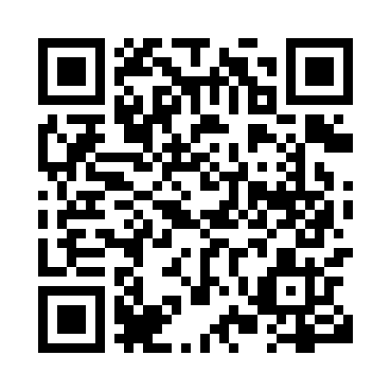
Prayer times for Gravel Lake, Yukon, Canada
Wed 1 May 2024 - Fri 31 May 2024
High Latitude Method: Angle Based Rule
Prayer Calculation Method: Islamic Society of North America
Asar Calculation Method: Hanafi

Date | Day | Fajr | Sunrise | Dhuhr | Asr | Maghrib | Isha
1 | Wed | 3:56 | 5:43 | 2:09 | 7:33 | 10:36 | 12:23
2 | Thu | 3:55 | 5:40 | 2:09 | 7:35 | 10:39 | 12:24
3 | Fri | 3:53 | 5:37 | 2:08 | 7:36 | 10:42 | 12:26
4 | Sat | 3:51 | 5:33 | 2:08 | 7:38 | 10:45 | 12:27
5 | Sun | 3:50 | 5:30 | 2:08 | 7:40 | 10:48 | 12:29
6 | Mon | 3:48 | 5:27 | 2:08 | 7:41 | 10:51 | 12:30
7 | Tue | 3:46 | 5:23 | 2:08 | 7:43 | 10:55 | 12:32
8 | Wed | 3:45 | 5:20 | 2:08 | 7:45 | 10:58 | 12:33
9 | Thu | 3:43 | 5:17 | 2:08 | 7:46 | 11:01 | 12:35
10 | Fri | 3:41 | 5:14 | 2:08 | 7:48 | 11:04 | 12:36
11 | Sat | 3:40 | 5:10 | 2:08 | 7:49 | 11:07 | 12:38
12 | Sun | 3:38 | 5:07 | 2:08 | 7:51 | 11:10 | 12:40
13 | Mon | 3:36 | 5:04 | 2:08 | 7:52 | 11:14 | 12:41
14 | Tue | 3:35 | 5:01 | 2:08 | 7:54 | 11:17 | 12:43
15 | Wed | 3:33 | 4:58 | 2:08 | 7:55 | 11:20 | 12:44
16 | Thu | 3:32 | 4:55 | 2:08 | 7:57 | 11:23 | 12:46
17 | Fri | 3:30 | 4:52 | 2:08 | 7:58 | 11:26 | 12:48
18 | Sat | 3:29 | 4:49 | 2:08 | 8:00 | 11:29 | 12:49
19 | Sun | 3:27 | 4:46 | 2:08 | 8:01 | 11:32 | 12:51
20 | Mon | 3:26 | 4:43 | 2:08 | 8:02 | 11:35 | 12:52
21 | Tue | 3:24 | 4:40 | 2:08 | 8:04 | 11:39 | 12:54
22 | Wed | 3:23 | 4:37 | 2:08 | 8:05 | 11:42 | 12:55
23 | Thu | 3:22 | 4:34 | 2:08 | 8:06 | 11:45 | 12:57
24 | Fri | 3:20 | 4:31 | 2:09 | 8:08 | 11:48 | 12:58
25 | Sat | 3:19 | 4:28 | 2:09 | 8:09 | 11:51 | 1:00
26 | Sun | 3:18 | 4:26 | 2:09 | 8:10 | 11:54 | 1:02
27 | Mon | 3:16 | 4:23 | 2:09 | 8:11 | 11:56 | 1:03
28 | Tue | 3:15 | 4:20 | 2:09 | 8:12 | 11:59 | 1:04
29 | Wed | 3:14 | 4:18 | 2:09 | 8:13 | 12:02 | 1:06
30 | Thu | 3:13 | 4:15 | 2:09 | 8:14 | 12:05 | 1:07
31 | Fri | 3:11 | 4:13 | 2:09 | 8:15 | 12:07 | 1:09
Prayer times provided by https://www.salahtimes.com

