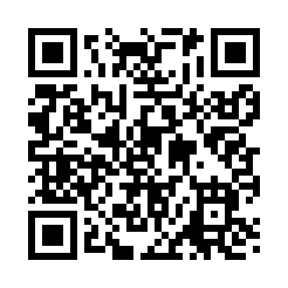
Prayer times for Bluestem, Washington, USA
Mon 1 Jul 2024 - Wed 31 Jul 2024
High Latitude Method: Angle Based Rule
Prayer Calculation Method: Islamic Society of North America
Asar Calculation Method: Shafi

Date | Day | Fajr | Sunrise | Dhuhr | Asr | Maghrib | Isha
1 | Mon | 2:58 | 5:00 | 12:57 | 5:10 | 8:53 | 10:55
2 | Tue | 2:58 | 5:00 | 12:57 | 5:10 | 8:53 | 10:55
3 | Wed | 2:59 | 5:01 | 12:57 | 5:10 | 8:53 | 10:55
4 | Thu | 2:59 | 5:02 | 12:57 | 5:10 | 8:52 | 10:55
5 | Fri | 3:00 | 5:02 | 12:57 | 5:10 | 8:52 | 10:54
6 | Sat | 3:00 | 5:03 | 12:57 | 5:10 | 8:51 | 10:54
7 | Sun | 3:01 | 5:04 | 12:58 | 5:10 | 8:51 | 10:54
8 | Mon | 3:01 | 5:05 | 12:58 | 5:10 | 8:50 | 10:54
9 | Tue | 3:02 | 5:06 | 12:58 | 5:10 | 8:50 | 10:54
10 | Wed | 3:02 | 5:07 | 12:58 | 5:10 | 8:49 | 10:53
11 | Thu | 3:03 | 5:08 | 12:58 | 5:10 | 8:48 | 10:52
12 | Fri | 3:05 | 5:08 | 12:58 | 5:10 | 8:48 | 10:51
13 | Sat | 3:07 | 5:09 | 12:58 | 5:10 | 8:47 | 10:49
14 | Sun | 3:08 | 5:10 | 12:58 | 5:10 | 8:46 | 10:48
15 | Mon | 3:10 | 5:11 | 12:59 | 5:09 | 8:45 | 10:46
16 | Tue | 3:12 | 5:12 | 12:59 | 5:09 | 8:44 | 10:44
17 | Wed | 3:14 | 5:13 | 12:59 | 5:09 | 8:44 | 10:43
18 | Thu | 3:16 | 5:15 | 12:59 | 5:09 | 8:43 | 10:41
19 | Fri | 3:18 | 5:16 | 12:59 | 5:08 | 8:42 | 10:39
20 | Sat | 3:20 | 5:17 | 12:59 | 5:08 | 8:41 | 10:37
21 | Sun | 3:21 | 5:18 | 12:59 | 5:08 | 8:40 | 10:35
22 | Mon | 3:23 | 5:19 | 12:59 | 5:07 | 8:38 | 10:34
23 | Tue | 3:25 | 5:20 | 12:59 | 5:07 | 8:37 | 10:32
24 | Wed | 3:27 | 5:21 | 12:59 | 5:07 | 8:36 | 10:30
25 | Thu | 3:29 | 5:23 | 12:59 | 5:06 | 8:35 | 10:28
26 | Fri | 3:31 | 5:24 | 12:59 | 5:06 | 8:34 | 10:26
27 | Sat | 3:33 | 5:25 | 12:59 | 5:05 | 8:32 | 10:24
28 | Sun | 3:35 | 5:26 | 12:59 | 5:05 | 8:31 | 10:22
29 | Mon | 3:37 | 5:27 | 12:59 | 5:04 | 8:30 | 10:20
30 | Tue | 3:39 | 5:29 | 12:59 | 5:04 | 8:29 | 10:17
31 | Wed | 3:41 | 5:30 | 12:59 | 5:03 | 8:27 | 10:15
Prayer times provided by https://www.salahtimes.com

