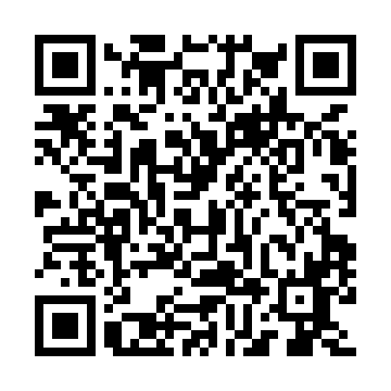
Prayer times for Uhukanatshehu, Quebec, Canada
Wed 1 May 2024 - Fri 31 May 2024
High Latitude Method: Angle Based Rule
Prayer Calculation Method: Islamic Society of North America
Asar Calculation Method: Hanafi

Date | Day | Fajr | Sunrise | Dhuhr | Asr | Maghrib | Isha
1 | Wed | 2:55 | 4:48 | 12:13 | 5:19 | 7:38 | 9:32
2 | Thu | 2:52 | 4:47 | 12:13 | 5:20 | 7:39 | 9:34
3 | Fri | 2:49 | 4:45 | 12:12 | 5:21 | 7:41 | 9:37
4 | Sat | 2:47 | 4:43 | 12:12 | 5:22 | 7:42 | 9:39
5 | Sun | 2:44 | 4:41 | 12:12 | 5:23 | 7:44 | 9:42
6 | Mon | 2:41 | 4:40 | 12:12 | 5:24 | 7:46 | 9:45
7 | Tue | 2:38 | 4:38 | 12:12 | 5:25 | 7:47 | 9:47
8 | Wed | 2:36 | 4:36 | 12:12 | 5:26 | 7:49 | 9:50
9 | Thu | 2:33 | 4:35 | 12:12 | 5:27 | 7:50 | 9:53
10 | Fri | 2:30 | 4:33 | 12:12 | 5:28 | 7:52 | 9:55
11 | Sat | 2:27 | 4:32 | 12:12 | 5:29 | 7:53 | 9:58
12 | Sun | 2:25 | 4:30 | 12:12 | 5:30 | 7:55 | 10:01
13 | Mon | 2:22 | 4:29 | 12:12 | 5:30 | 7:56 | 10:03
14 | Tue | 2:20 | 4:27 | 12:12 | 5:31 | 7:58 | 10:05
15 | Wed | 2:19 | 4:26 | 12:12 | 5:32 | 7:59 | 10:06
16 | Thu | 2:18 | 4:24 | 12:12 | 5:33 | 8:00 | 10:06
17 | Fri | 2:18 | 4:23 | 12:12 | 5:34 | 8:02 | 10:07
18 | Sat | 2:17 | 4:22 | 12:12 | 5:35 | 8:03 | 10:08
19 | Sun | 2:16 | 4:20 | 12:12 | 5:36 | 8:05 | 10:09
20 | Mon | 2:16 | 4:19 | 12:12 | 5:36 | 8:06 | 10:09
21 | Tue | 2:15 | 4:18 | 12:12 | 5:37 | 8:07 | 10:10
22 | Wed | 2:15 | 4:17 | 12:12 | 5:38 | 8:09 | 10:11
23 | Thu | 2:14 | 4:16 | 12:12 | 5:39 | 8:10 | 10:11
24 | Fri | 2:14 | 4:14 | 12:13 | 5:39 | 8:11 | 10:12
25 | Sat | 2:13 | 4:13 | 12:13 | 5:40 | 8:13 | 10:13
26 | Sun | 2:13 | 4:12 | 12:13 | 5:41 | 8:14 | 10:13
27 | Mon | 2:12 | 4:11 | 12:13 | 5:42 | 8:15 | 10:14
28 | Tue | 2:12 | 4:10 | 12:13 | 5:42 | 8:16 | 10:15
29 | Wed | 2:11 | 4:10 | 12:13 | 5:43 | 8:17 | 10:15
30 | Thu | 2:11 | 4:09 | 12:13 | 5:44 | 8:18 | 10:16
31 | Fri | 2:11 | 4:08 | 12:13 | 5:44 | 8:19 | 10:17
Prayer times provided by https://www.salahtimes.com

