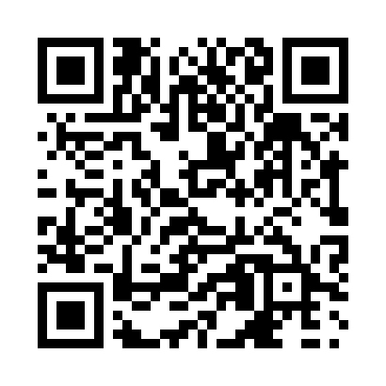
Prayer times for Tuttusivik, Quebec, Canada
Mon 1 Apr 2024 - Tue 30 Apr 2024
High Latitude Method: Angle Based Rule
Prayer Calculation Method: Islamic Society of North America
Asar Calculation Method: Hanafi

Date | Day | Fajr | Sunrise | Dhuhr | Asr | Maghrib | Isha
1 | Mon | 4:12 | 6:18 | 12:58 | 5:21 | 7:40 | 9:46
2 | Tue | 4:08 | 6:15 | 12:58 | 5:23 | 7:42 | 9:50
3 | Wed | 4:04 | 6:12 | 12:58 | 5:24 | 7:45 | 9:53
4 | Thu | 4:00 | 6:09 | 12:57 | 5:26 | 7:47 | 9:57
5 | Fri | 3:56 | 6:06 | 12:57 | 5:28 | 7:49 | 10:00
6 | Sat | 3:52 | 6:03 | 12:57 | 5:30 | 7:52 | 10:04
7 | Sun | 3:47 | 6:00 | 12:56 | 5:31 | 7:54 | 10:08
8 | Mon | 3:43 | 5:57 | 12:56 | 5:33 | 7:57 | 10:11
9 | Tue | 3:39 | 5:54 | 12:56 | 5:35 | 7:59 | 10:15
10 | Wed | 3:34 | 5:51 | 12:56 | 5:36 | 8:02 | 10:19
11 | Thu | 3:30 | 5:48 | 12:55 | 5:38 | 8:04 | 10:23
12 | Fri | 3:25 | 5:45 | 12:55 | 5:40 | 8:06 | 10:28
13 | Sat | 3:20 | 5:42 | 12:55 | 5:41 | 8:09 | 10:32
14 | Sun | 3:17 | 5:39 | 12:55 | 5:43 | 8:11 | 10:33
15 | Mon | 3:16 | 5:36 | 12:54 | 5:45 | 8:14 | 10:34
16 | Tue | 3:14 | 5:33 | 12:54 | 5:46 | 8:16 | 10:36
17 | Wed | 3:12 | 5:30 | 12:54 | 5:48 | 8:19 | 10:37
18 | Thu | 3:11 | 5:28 | 12:54 | 5:50 | 8:21 | 10:38
19 | Fri | 3:09 | 5:25 | 12:53 | 5:51 | 8:24 | 10:39
20 | Sat | 3:08 | 5:22 | 12:53 | 5:53 | 8:26 | 10:40
21 | Sun | 3:06 | 5:19 | 12:53 | 5:54 | 8:29 | 10:41
22 | Mon | 3:05 | 5:16 | 12:53 | 5:56 | 8:31 | 10:42
23 | Tue | 3:03 | 5:13 | 12:53 | 5:57 | 8:34 | 10:43
24 | Wed | 3:02 | 5:10 | 12:53 | 5:59 | 8:36 | 10:45
25 | Thu | 3:00 | 5:08 | 12:52 | 6:01 | 8:38 | 10:46
26 | Fri | 2:59 | 5:05 | 12:52 | 6:02 | 8:41 | 10:47
27 | Sat | 2:57 | 5:02 | 12:52 | 6:04 | 8:43 | 10:48
28 | Sun | 2:56 | 4:59 | 12:52 | 6:05 | 8:46 | 10:49
29 | Mon | 2:54 | 4:56 | 12:52 | 6:07 | 8:48 | 10:50
30 | Tue | 2:53 | 4:54 | 12:52 | 6:08 | 8:51 | 10:52
Prayer times provided by https://www.salahtimes.com

