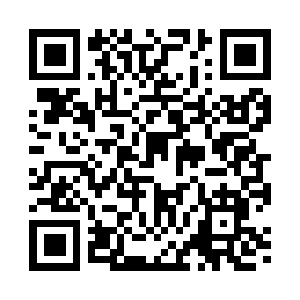
Prayer times for Alverson, New York, USA
Wed 1 May 2024 - Fri 31 May 2024
High Latitude Method: Angle Based Rule
Prayer Calculation Method: Islamic Society of North America
Asar Calculation Method: Shafi

Date | Day | Fajr | Sunrise | Dhuhr | Asr | Maghrib | Isha
1 | Wed | 4:23 | 5:55 | 1:01 | 4:56 | 8:08 | 9:40
2 | Thu | 4:21 | 5:54 | 1:01 | 4:57 | 8:09 | 9:42
3 | Fri | 4:19 | 5:52 | 1:01 | 4:57 | 8:10 | 9:43
4 | Sat | 4:18 | 5:51 | 1:01 | 4:58 | 8:11 | 9:45
5 | Sun | 4:16 | 5:50 | 1:01 | 4:58 | 8:13 | 9:47
6 | Mon | 4:14 | 5:48 | 1:01 | 4:58 | 8:14 | 9:48
7 | Tue | 4:12 | 5:47 | 1:01 | 4:59 | 8:15 | 9:50
8 | Wed | 4:10 | 5:46 | 1:01 | 4:59 | 8:16 | 9:52
9 | Thu | 4:09 | 5:44 | 1:01 | 4:59 | 8:17 | 9:53
10 | Fri | 4:07 | 5:43 | 1:00 | 5:00 | 8:18 | 9:55
11 | Sat | 4:05 | 5:42 | 1:00 | 5:00 | 8:20 | 9:57
12 | Sun | 4:04 | 5:41 | 1:00 | 5:01 | 8:21 | 9:58
13 | Mon | 4:02 | 5:40 | 1:00 | 5:01 | 8:22 | 10:00
14 | Tue | 4:00 | 5:39 | 1:00 | 5:01 | 8:23 | 10:02
15 | Wed | 3:59 | 5:38 | 1:00 | 5:02 | 8:24 | 10:03
16 | Thu | 3:57 | 5:36 | 1:01 | 5:02 | 8:25 | 10:05
17 | Fri | 3:56 | 5:35 | 1:01 | 5:02 | 8:26 | 10:06
18 | Sat | 3:54 | 5:34 | 1:01 | 5:03 | 8:27 | 10:08
19 | Sun | 3:53 | 5:34 | 1:01 | 5:03 | 8:28 | 10:10
20 | Mon | 3:51 | 5:33 | 1:01 | 5:03 | 8:29 | 10:11
21 | Tue | 3:50 | 5:32 | 1:01 | 5:04 | 8:30 | 10:13
22 | Wed | 3:48 | 5:31 | 1:01 | 5:04 | 8:31 | 10:14
23 | Thu | 3:47 | 5:30 | 1:01 | 5:05 | 8:32 | 10:16
24 | Fri | 3:46 | 5:29 | 1:01 | 5:05 | 8:33 | 10:17
25 | Sat | 3:44 | 5:28 | 1:01 | 5:05 | 8:34 | 10:19
26 | Sun | 3:43 | 5:28 | 1:01 | 5:06 | 8:35 | 10:20
27 | Mon | 3:42 | 5:27 | 1:01 | 5:06 | 8:36 | 10:21
28 | Tue | 3:41 | 5:26 | 1:01 | 5:06 | 8:37 | 10:23
29 | Wed | 3:40 | 5:26 | 1:02 | 5:07 | 8:38 | 10:24
30 | Thu | 3:39 | 5:25 | 1:02 | 5:07 | 8:39 | 10:25
31 | Fri | 3:38 | 5:25 | 1:02 | 5:07 | 8:40 | 10:27
Prayer times provided by https://www.salahtimes.com

