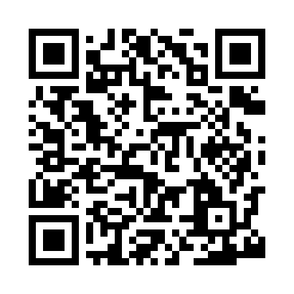
Prayer times for Aird Barvas, UK
Wed 1 May 2024 - Fri 31 May 2024
High Latitude Method: Angle Based Rule
Prayer Calculation Method: Islamic Society of North America
Asar Calculation Method: Hanafi

Date | Day | Fajr | Sunrise | Dhuhr | Asr | Maghrib | Isha
1 | Wed | 3:27 | 5:31 | 1:23 | 6:39 | 9:17 | 11:20
2 | Thu | 3:26 | 5:28 | 1:23 | 6:40 | 9:19 | 11:21
3 | Fri | 3:25 | 5:26 | 1:23 | 6:41 | 9:21 | 11:22
4 | Sat | 3:23 | 5:23 | 1:23 | 6:43 | 9:24 | 11:23
5 | Sun | 3:22 | 5:21 | 1:23 | 6:44 | 9:26 | 11:25
6 | Mon | 3:21 | 5:18 | 1:23 | 6:45 | 9:28 | 11:26
7 | Tue | 3:20 | 5:16 | 1:23 | 6:47 | 9:30 | 11:27
8 | Wed | 3:18 | 5:14 | 1:23 | 6:48 | 9:33 | 11:28
9 | Thu | 3:17 | 5:11 | 1:23 | 6:49 | 9:35 | 11:29
10 | Fri | 3:16 | 5:09 | 1:22 | 6:50 | 9:37 | 11:30
11 | Sat | 3:15 | 5:07 | 1:22 | 6:52 | 9:39 | 11:31
12 | Sun | 3:14 | 5:05 | 1:22 | 6:53 | 9:41 | 11:32
13 | Mon | 3:13 | 5:02 | 1:22 | 6:54 | 9:43 | 11:33
14 | Tue | 3:12 | 5:00 | 1:22 | 6:55 | 9:46 | 11:34
15 | Wed | 3:11 | 4:58 | 1:22 | 6:56 | 9:48 | 11:35
16 | Thu | 3:10 | 4:56 | 1:22 | 6:58 | 9:50 | 11:36
17 | Fri | 3:09 | 4:54 | 1:22 | 6:59 | 9:52 | 11:37
18 | Sat | 3:08 | 4:52 | 1:23 | 7:00 | 9:54 | 11:38
19 | Sun | 3:07 | 4:50 | 1:23 | 7:01 | 9:56 | 11:40
20 | Mon | 3:06 | 4:48 | 1:23 | 7:02 | 9:58 | 11:41
21 | Tue | 3:05 | 4:46 | 1:23 | 7:03 | 10:00 | 11:42
22 | Wed | 3:04 | 4:45 | 1:23 | 7:04 | 10:02 | 11:43
23 | Thu | 3:03 | 4:43 | 1:23 | 7:05 | 10:04 | 11:44
24 | Fri | 3:02 | 4:41 | 1:23 | 7:06 | 10:06 | 11:45
25 | Sat | 3:01 | 4:39 | 1:23 | 7:07 | 10:08 | 11:46
26 | Sun | 3:01 | 4:38 | 1:23 | 7:08 | 10:09 | 11:47
27 | Mon | 3:00 | 4:36 | 1:23 | 7:09 | 10:11 | 11:47
28 | Tue | 2:59 | 4:35 | 1:23 | 7:10 | 10:13 | 11:48
29 | Wed | 2:59 | 4:33 | 1:24 | 7:11 | 10:15 | 11:49
30 | Thu | 2:58 | 4:32 | 1:24 | 7:12 | 10:16 | 11:50
31 | Fri | 2:57 | 4:31 | 1:24 | 7:13 | 10:18 | 11:51
Prayer times provided by https://www.salahtimes.com

