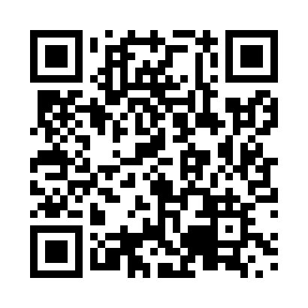
Prayer times for Theresa, Ontario, Canada
Wed 1 May 2024 - Fri 31 May 2024
High Latitude Method: Angle Based Rule
Prayer Calculation Method: Islamic Society of North America
Asar Calculation Method: Hanafi

Date | Day | Fajr | Sunrise | Dhuhr | Asr | Maghrib | Isha
1 | Wed | 4:33 | 6:22 | 1:43 | 6:49 | 9:05 | 10:54
2 | Thu | 4:31 | 6:20 | 1:43 | 6:50 | 9:06 | 10:57
3 | Fri | 4:28 | 6:19 | 1:43 | 6:50 | 9:08 | 10:59
4 | Sat | 4:25 | 6:17 | 1:43 | 6:51 | 9:09 | 11:02
5 | Sun | 4:23 | 6:15 | 1:43 | 6:52 | 9:11 | 11:04
6 | Mon | 4:20 | 6:14 | 1:43 | 6:53 | 9:12 | 11:06
7 | Tue | 4:18 | 6:12 | 1:43 | 6:54 | 9:14 | 11:09
8 | Wed | 4:15 | 6:11 | 1:43 | 6:55 | 9:15 | 11:11
9 | Thu | 4:13 | 6:09 | 1:43 | 6:56 | 9:17 | 11:14
10 | Fri | 4:10 | 6:08 | 1:42 | 6:57 | 9:18 | 11:16
11 | Sat | 4:08 | 6:06 | 1:42 | 6:58 | 9:20 | 11:18
12 | Sun | 4:05 | 6:05 | 1:42 | 6:58 | 9:21 | 11:21
13 | Mon | 4:03 | 6:03 | 1:42 | 6:59 | 9:22 | 11:23
14 | Tue | 4:00 | 6:02 | 1:42 | 7:00 | 9:24 | 11:26
15 | Wed | 3:58 | 6:00 | 1:42 | 7:01 | 9:25 | 11:28
16 | Thu | 3:56 | 5:59 | 1:42 | 7:02 | 9:27 | 11:31
17 | Fri | 3:53 | 5:58 | 1:43 | 7:02 | 9:28 | 11:33
18 | Sat | 3:51 | 5:56 | 1:43 | 7:03 | 9:29 | 11:36
19 | Sun | 3:49 | 5:55 | 1:43 | 7:04 | 9:31 | 11:37
20 | Mon | 3:49 | 5:54 | 1:43 | 7:05 | 9:32 | 11:37
21 | Tue | 3:48 | 5:53 | 1:43 | 7:06 | 9:33 | 11:38
22 | Wed | 3:47 | 5:52 | 1:43 | 7:06 | 9:34 | 11:39
23 | Thu | 3:47 | 5:51 | 1:43 | 7:07 | 9:36 | 11:39
24 | Fri | 3:46 | 5:50 | 1:43 | 7:08 | 9:37 | 11:40
25 | Sat | 3:46 | 5:49 | 1:43 | 7:08 | 9:38 | 11:41
26 | Sun | 3:46 | 5:48 | 1:43 | 7:09 | 9:39 | 11:41
27 | Mon | 3:45 | 5:47 | 1:43 | 7:10 | 9:40 | 11:42
28 | Tue | 3:45 | 5:46 | 1:43 | 7:11 | 9:42 | 11:43
29 | Wed | 3:44 | 5:45 | 1:44 | 7:11 | 9:43 | 11:43
30 | Thu | 3:44 | 5:44 | 1:44 | 7:12 | 9:44 | 11:44
31 | Fri | 3:44 | 5:44 | 1:44 | 7:12 | 9:45 | 11:44
Prayer times provided by https://www.salahtimes.com

