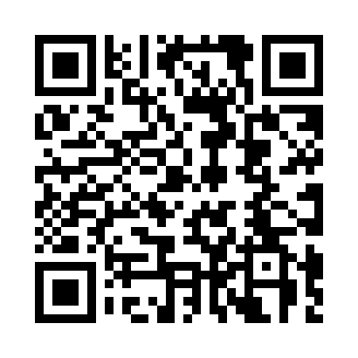
Prayer times for Tolsmaville, Ontario, Canada
Wed 1 May 2024 - Fri 31 May 2024
High Latitude Method: Angle Based Rule
Prayer Calculation Method: Islamic Society of North America
Asar Calculation Method: Hanafi

Date | Day | Fajr | Sunrise | Dhuhr | Asr | Maghrib | Isha
1 | Wed | 4:42 | 6:19 | 1:30 | 6:32 | 8:42 | 10:19
2 | Thu | 4:40 | 6:18 | 1:30 | 6:33 | 8:43 | 10:21
3 | Fri | 4:38 | 6:16 | 1:30 | 6:33 | 8:45 | 10:23
4 | Sat | 4:36 | 6:15 | 1:30 | 6:34 | 8:46 | 10:25
5 | Sun | 4:34 | 6:13 | 1:30 | 6:35 | 8:47 | 10:27
6 | Mon | 4:32 | 6:12 | 1:30 | 6:36 | 8:48 | 10:29
7 | Tue | 4:30 | 6:11 | 1:30 | 6:36 | 8:50 | 10:30
8 | Wed | 4:28 | 6:09 | 1:30 | 6:37 | 8:51 | 10:32
9 | Thu | 4:26 | 6:08 | 1:30 | 6:38 | 8:52 | 10:34
10 | Fri | 4:24 | 6:07 | 1:30 | 6:39 | 8:53 | 10:36
11 | Sat | 4:23 | 6:05 | 1:30 | 6:39 | 8:55 | 10:38
12 | Sun | 4:21 | 6:04 | 1:30 | 6:40 | 8:56 | 10:40
13 | Mon | 4:19 | 6:03 | 1:30 | 6:41 | 8:57 | 10:42
14 | Tue | 4:17 | 6:02 | 1:30 | 6:41 | 8:58 | 10:43
15 | Wed | 4:15 | 6:01 | 1:30 | 6:42 | 8:59 | 10:45
16 | Thu | 4:13 | 5:59 | 1:30 | 6:43 | 9:01 | 10:47
17 | Fri | 4:12 | 5:58 | 1:30 | 6:44 | 9:02 | 10:49
18 | Sat | 4:10 | 5:57 | 1:30 | 6:44 | 9:03 | 10:51
19 | Sun | 4:08 | 5:56 | 1:30 | 6:45 | 9:04 | 10:52
20 | Mon | 4:06 | 5:55 | 1:30 | 6:46 | 9:05 | 10:54
21 | Tue | 4:05 | 5:54 | 1:30 | 6:46 | 9:06 | 10:56
22 | Wed | 4:03 | 5:53 | 1:30 | 6:47 | 9:07 | 10:58
23 | Thu | 4:02 | 5:52 | 1:30 | 6:47 | 9:08 | 10:59
24 | Fri | 4:00 | 5:52 | 1:30 | 6:48 | 9:09 | 11:01
25 | Sat | 3:59 | 5:51 | 1:30 | 6:49 | 9:10 | 11:03
26 | Sun | 3:57 | 5:50 | 1:30 | 6:49 | 9:11 | 11:04
27 | Mon | 3:56 | 5:49 | 1:31 | 6:50 | 9:12 | 11:06
28 | Tue | 3:55 | 5:48 | 1:31 | 6:51 | 9:13 | 11:08
29 | Wed | 3:53 | 5:48 | 1:31 | 6:51 | 9:14 | 11:09
30 | Thu | 3:52 | 5:47 | 1:31 | 6:52 | 9:15 | 11:11
31 | Fri | 3:51 | 5:46 | 1:31 | 6:52 | 9:16 | 11:12
Prayer times provided by https://www.salahtimes.com

