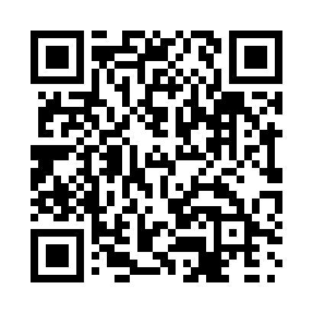
Prayer times for Dengy Place, Quebec, Canada
Mon 1 Apr 2024 - Tue 30 Apr 2024
High Latitude Method: Angle Based Rule
Prayer Calculation Method: Islamic Society of North America
Asar Calculation Method: Hanafi

Date | Day | Fajr | Sunrise | Dhuhr | Asr | Maghrib | Isha
1 | Mon | 3:55 | 5:30 | 11:59 | 4:27 | 6:29 | 8:05
2 | Tue | 3:52 | 5:28 | 11:59 | 4:28 | 6:31 | 8:07
3 | Wed | 3:50 | 5:26 | 11:59 | 4:29 | 6:33 | 8:09
4 | Thu | 3:47 | 5:23 | 11:58 | 4:30 | 6:34 | 8:11
5 | Fri | 3:44 | 5:21 | 11:58 | 4:31 | 6:36 | 8:13
6 | Sat | 3:42 | 5:19 | 11:58 | 4:33 | 6:37 | 8:15
7 | Sun | 3:39 | 5:17 | 11:57 | 4:34 | 6:39 | 8:17
8 | Mon | 3:36 | 5:14 | 11:57 | 4:35 | 6:41 | 8:19
9 | Tue | 3:34 | 5:12 | 11:57 | 4:36 | 6:42 | 8:21
10 | Wed | 3:31 | 5:10 | 11:57 | 4:37 | 6:44 | 8:24
11 | Thu | 3:28 | 5:08 | 11:56 | 4:38 | 6:46 | 8:26
12 | Fri | 3:26 | 5:06 | 11:56 | 4:39 | 6:47 | 8:28
13 | Sat | 3:23 | 5:04 | 11:56 | 4:41 | 6:49 | 8:30
14 | Sun | 3:20 | 5:02 | 11:56 | 4:42 | 6:51 | 8:32
15 | Mon | 3:17 | 4:59 | 11:55 | 4:43 | 6:52 | 8:35
16 | Tue | 3:15 | 4:57 | 11:55 | 4:44 | 6:54 | 8:37
17 | Wed | 3:12 | 4:55 | 11:55 | 4:45 | 6:55 | 8:39
18 | Thu | 3:09 | 4:53 | 11:55 | 4:46 | 6:57 | 8:42
19 | Fri | 3:06 | 4:51 | 11:54 | 4:47 | 6:59 | 8:44
20 | Sat | 3:04 | 4:49 | 11:54 | 4:48 | 7:00 | 8:46
21 | Sun | 3:01 | 4:47 | 11:54 | 4:49 | 7:02 | 8:49
22 | Mon | 2:58 | 4:45 | 11:54 | 4:50 | 7:04 | 8:51
23 | Tue | 2:55 | 4:43 | 11:54 | 4:51 | 7:05 | 8:53
24 | Wed | 2:53 | 4:41 | 11:54 | 4:52 | 7:07 | 8:56
25 | Thu | 2:50 | 4:39 | 11:53 | 4:53 | 7:09 | 8:58
26 | Fri | 2:47 | 4:37 | 11:53 | 4:54 | 7:10 | 9:01
27 | Sat | 2:44 | 4:35 | 11:53 | 4:55 | 7:12 | 9:03
28 | Sun | 2:41 | 4:33 | 11:53 | 4:56 | 7:13 | 9:06
29 | Mon | 2:39 | 4:31 | 11:53 | 4:57 | 7:15 | 9:08
30 | Tue | 2:36 | 4:29 | 11:53 | 4:58 | 7:17 | 9:11
Prayer times provided by https://www.salahtimes.com

