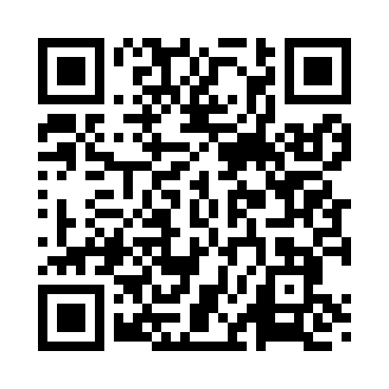
Prayer times for Yuba, California, USA
Sat 1 Jun 2024 - Sun 30 Jun 2024
High Latitude Method: Angle Based Rule
Prayer Calculation Method: Islamic Society of North America
Asar Calculation Method: Shafi

Date | Day | Fajr | Sunrise | Dhuhr | Asr | Maghrib | Isha
1 | Sat | 4:09 | 5:42 | 1:04 | 5:00 | 8:27 | 10:00
2 | Sun | 4:09 | 5:42 | 1:04 | 5:00 | 8:28 | 10:01
3 | Mon | 4:08 | 5:41 | 1:05 | 5:01 | 8:28 | 10:02
4 | Tue | 4:08 | 5:41 | 1:05 | 5:01 | 8:29 | 10:02
5 | Wed | 4:07 | 5:41 | 1:05 | 5:01 | 8:29 | 10:03
6 | Thu | 4:07 | 5:40 | 1:05 | 5:02 | 8:30 | 10:04
7 | Fri | 4:06 | 5:40 | 1:05 | 5:02 | 8:31 | 10:05
8 | Sat | 4:06 | 5:40 | 1:06 | 5:02 | 8:31 | 10:05
9 | Sun | 4:06 | 5:40 | 1:06 | 5:02 | 8:32 | 10:06
10 | Mon | 4:05 | 5:40 | 1:06 | 5:03 | 8:32 | 10:07
11 | Tue | 4:05 | 5:40 | 1:06 | 5:03 | 8:33 | 10:07
12 | Wed | 4:05 | 5:40 | 1:06 | 5:03 | 8:33 | 10:08
13 | Thu | 4:05 | 5:40 | 1:07 | 5:03 | 8:34 | 10:09
14 | Fri | 4:05 | 5:40 | 1:07 | 5:03 | 8:34 | 10:09
15 | Sat | 4:05 | 5:40 | 1:07 | 5:04 | 8:34 | 10:09
16 | Sun | 4:05 | 5:40 | 1:07 | 5:04 | 8:35 | 10:10
17 | Mon | 4:05 | 5:40 | 1:07 | 5:04 | 8:35 | 10:10
18 | Tue | 4:05 | 5:40 | 1:08 | 5:04 | 8:35 | 10:11
19 | Wed | 4:05 | 5:40 | 1:08 | 5:05 | 8:35 | 10:11
20 | Thu | 4:05 | 5:40 | 1:08 | 5:05 | 8:36 | 10:11
21 | Fri | 4:05 | 5:41 | 1:08 | 5:05 | 8:36 | 10:11
22 | Sat | 4:06 | 5:41 | 1:08 | 5:05 | 8:36 | 10:11
23 | Sun | 4:06 | 5:41 | 1:09 | 5:06 | 8:36 | 10:11
24 | Mon | 4:06 | 5:41 | 1:09 | 5:06 | 8:36 | 10:12
25 | Tue | 4:07 | 5:42 | 1:09 | 5:06 | 8:36 | 10:12
26 | Wed | 4:07 | 5:42 | 1:09 | 5:06 | 8:36 | 10:11
27 | Thu | 4:08 | 5:43 | 1:10 | 5:06 | 8:36 | 10:11
28 | Fri | 4:08 | 5:43 | 1:10 | 5:06 | 8:36 | 10:11
29 | Sat | 4:09 | 5:43 | 1:10 | 5:07 | 8:36 | 10:11
30 | Sun | 4:09 | 5:44 | 1:10 | 5:07 | 8:36 | 10:11
Prayer times provided by https://www.salahtimes.com

