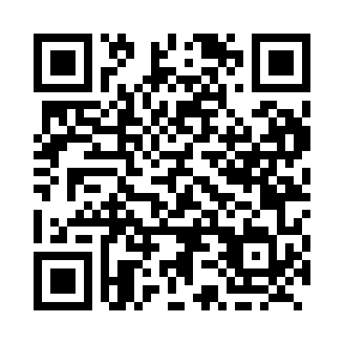
Prayer times for Neebing, Ontario, Canada
Mon 1 Jul 2024 - Wed 31 Jul 2024
High Latitude Method: Angle Based Rule
Prayer Calculation Method: Islamic Society of North America
Asar Calculation Method: Hanafi

Date | Day | Fajr | Sunrise | Dhuhr | Asr | Maghrib | Isha
1 | Mon | 4:02 | 6:02 | 2:02 | 7:31 | 10:02 | 12:02
2 | Tue | 4:02 | 6:03 | 2:02 | 7:30 | 10:01 | 12:02
3 | Wed | 4:03 | 6:03 | 2:02 | 7:30 | 10:01 | 12:02
4 | Thu | 4:03 | 6:04 | 2:02 | 7:30 | 10:01 | 12:01
5 | Fri | 4:04 | 6:05 | 2:03 | 7:30 | 10:00 | 12:01
6 | Sat | 4:04 | 6:06 | 2:03 | 7:30 | 10:00 | 12:01
7 | Sun | 4:05 | 6:06 | 2:03 | 7:30 | 9:59 | 12:01
8 | Mon | 4:05 | 6:07 | 2:03 | 7:30 | 9:59 | 12:01
9 | Tue | 4:06 | 6:08 | 2:03 | 7:29 | 9:58 | 12:01
10 | Wed | 4:06 | 6:09 | 2:03 | 7:29 | 9:57 | 12:00
11 | Thu | 4:07 | 6:10 | 2:04 | 7:29 | 9:57 | 12:00
12 | Fri | 4:07 | 6:11 | 2:04 | 7:28 | 9:56 | 12:00
13 | Sat | 4:08 | 6:12 | 2:04 | 7:28 | 9:55 | 11:59
14 | Sun | 4:08 | 6:13 | 2:04 | 7:28 | 9:54 | 11:59
15 | Mon | 4:09 | 6:14 | 2:04 | 7:27 | 9:53 | 11:58
16 | Tue | 4:11 | 6:15 | 2:04 | 7:27 | 9:53 | 11:56
17 | Wed | 4:13 | 6:16 | 2:04 | 7:26 | 9:52 | 11:55
18 | Thu | 4:15 | 6:17 | 2:04 | 7:26 | 9:51 | 11:53
19 | Fri | 4:17 | 6:18 | 2:04 | 7:25 | 9:50 | 11:51
20 | Sat | 4:19 | 6:20 | 2:04 | 7:25 | 9:49 | 11:49
21 | Sun | 4:21 | 6:21 | 2:04 | 7:24 | 9:47 | 11:47
22 | Mon | 4:23 | 6:22 | 2:04 | 7:23 | 9:46 | 11:45
23 | Tue | 4:25 | 6:23 | 2:04 | 7:23 | 9:45 | 11:43
24 | Wed | 4:27 | 6:24 | 2:04 | 7:22 | 9:44 | 11:41
25 | Thu | 4:29 | 6:25 | 2:04 | 7:21 | 9:43 | 11:39
26 | Fri | 4:31 | 6:27 | 2:04 | 7:21 | 9:42 | 11:37
27 | Sat | 4:33 | 6:28 | 2:04 | 7:20 | 9:40 | 11:34
28 | Sun | 4:35 | 6:29 | 2:04 | 7:19 | 9:39 | 11:32
29 | Mon | 4:37 | 6:30 | 2:04 | 7:18 | 9:38 | 11:30
30 | Tue | 4:40 | 6:32 | 2:04 | 7:17 | 9:36 | 11:28
31 | Wed | 4:42 | 6:33 | 2:04 | 7:17 | 9:35 | 11:26
Prayer times provided by https://www.salahtimes.com

