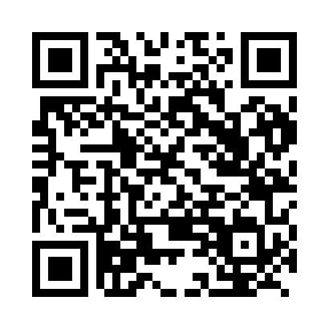
Prayer times for Bikti, Cameroon
Wed 1 May 2024 - Fri 31 May 2024
High Latitude Method: None
Prayer Calculation Method: Muslim World League
Asar Calculation Method: Shafi

Date | Day | Fajr | Sunrise | Dhuhr | Asr | Maghrib | Isha
1 | Wed | 4:48 | 6:00 | 12:09 | 3:27 | 6:18 | 7:25
2 | Thu | 4:47 | 5:59 | 12:09 | 3:27 | 6:18 | 7:26
3 | Fri | 4:47 | 5:59 | 12:08 | 3:27 | 6:18 | 7:26
4 | Sat | 4:47 | 5:59 | 12:08 | 3:28 | 6:18 | 7:26
5 | Sun | 4:46 | 5:59 | 12:08 | 3:28 | 6:18 | 7:26
6 | Mon | 4:46 | 5:59 | 12:08 | 3:28 | 6:18 | 7:26
7 | Tue | 4:46 | 5:58 | 12:08 | 3:29 | 6:18 | 7:26
8 | Wed | 4:46 | 5:58 | 12:08 | 3:29 | 6:18 | 7:27
9 | Thu | 4:45 | 5:58 | 12:08 | 3:29 | 6:18 | 7:27
10 | Fri | 4:45 | 5:58 | 12:08 | 3:29 | 6:18 | 7:27
11 | Sat | 4:45 | 5:58 | 12:08 | 3:30 | 6:18 | 7:27
12 | Sun | 4:44 | 5:58 | 12:08 | 3:30 | 6:18 | 7:27
13 | Mon | 4:44 | 5:58 | 12:08 | 3:30 | 6:18 | 7:27
14 | Tue | 4:44 | 5:57 | 12:08 | 3:31 | 6:19 | 7:28
15 | Wed | 4:44 | 5:57 | 12:08 | 3:31 | 6:19 | 7:28
16 | Thu | 4:44 | 5:57 | 12:08 | 3:31 | 6:19 | 7:28
17 | Fri | 4:43 | 5:57 | 12:08 | 3:31 | 6:19 | 7:28
18 | Sat | 4:43 | 5:57 | 12:08 | 3:32 | 6:19 | 7:29
19 | Sun | 4:43 | 5:57 | 12:08 | 3:32 | 6:19 | 7:29
20 | Mon | 4:43 | 5:57 | 12:08 | 3:32 | 6:19 | 7:29
21 | Tue | 4:43 | 5:57 | 12:08 | 3:32 | 6:19 | 7:29
22 | Wed | 4:43 | 5:57 | 12:08 | 3:33 | 6:20 | 7:30
23 | Thu | 4:43 | 5:57 | 12:08 | 3:33 | 6:20 | 7:30
24 | Fri | 4:43 | 5:57 | 12:09 | 3:33 | 6:20 | 7:30
25 | Sat | 4:42 | 5:57 | 12:09 | 3:34 | 6:20 | 7:30
26 | Sun | 4:42 | 5:57 | 12:09 | 3:34 | 6:20 | 7:31
27 | Mon | 4:42 | 5:57 | 12:09 | 3:34 | 6:21 | 7:31
28 | Tue | 4:42 | 5:57 | 12:09 | 3:34 | 6:21 | 7:31
29 | Wed | 4:42 | 5:57 | 12:09 | 3:35 | 6:21 | 7:32
30 | Thu | 4:42 | 5:57 | 12:09 | 3:35 | 6:21 | 7:32
31 | Fri | 4:42 | 5:57 | 12:09 | 3:35 | 6:21 | 7:32
Prayer times provided by https://www.salahtimes.com

