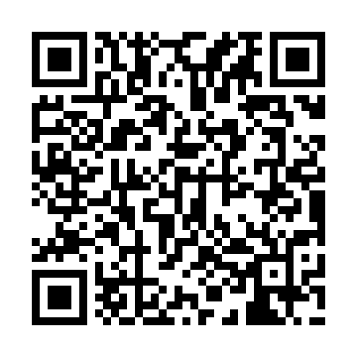
Prayer times for Crooked Island, Bahamas
Wed 1 May 2024 - Fri 31 May 2024
High Latitude Method: None
Prayer Calculation Method: Muslim World League
Asar Calculation Method: Shafi

Date | Day | Fajr | Sunrise | Dhuhr | Asr | Maghrib | Isha
1 | Wed | 5:04 | 6:24 | 12:54 | 4:18 | 7:24 | 8:40
2 | Thu | 5:03 | 6:23 | 12:54 | 4:17 | 7:25 | 8:40
3 | Fri | 5:02 | 6:23 | 12:54 | 4:17 | 7:25 | 8:41
4 | Sat | 5:01 | 6:22 | 12:54 | 4:17 | 7:26 | 8:41
5 | Sun | 5:01 | 6:21 | 12:54 | 4:16 | 7:26 | 8:42
6 | Mon | 5:00 | 6:21 | 12:53 | 4:16 | 7:26 | 8:43
7 | Tue | 4:59 | 6:20 | 12:53 | 4:16 | 7:27 | 8:43
8 | Wed | 4:58 | 6:20 | 12:53 | 4:16 | 7:27 | 8:44
9 | Thu | 4:58 | 6:19 | 12:53 | 4:15 | 7:28 | 8:45
10 | Fri | 4:57 | 6:18 | 12:53 | 4:15 | 7:28 | 8:45
11 | Sat | 4:56 | 6:18 | 12:53 | 4:15 | 7:29 | 8:46
12 | Sun | 4:55 | 6:17 | 12:53 | 4:15 | 7:29 | 8:46
13 | Mon | 4:55 | 6:17 | 12:53 | 4:14 | 7:30 | 8:47
14 | Tue | 4:54 | 6:17 | 12:53 | 4:14 | 7:30 | 8:48
15 | Wed | 4:53 | 6:16 | 12:53 | 4:14 | 7:31 | 8:48
16 | Thu | 4:53 | 6:16 | 12:53 | 4:14 | 7:31 | 8:49
17 | Fri | 4:52 | 6:15 | 12:53 | 4:13 | 7:32 | 8:50
18 | Sat | 4:52 | 6:15 | 12:53 | 4:13 | 7:32 | 8:50
19 | Sun | 4:51 | 6:15 | 12:53 | 4:13 | 7:32 | 8:51
20 | Mon | 4:51 | 6:14 | 12:53 | 4:13 | 7:33 | 8:51
21 | Tue | 4:50 | 6:14 | 12:54 | 4:13 | 7:33 | 8:52
22 | Wed | 4:50 | 6:14 | 12:54 | 4:13 | 7:34 | 8:53
23 | Thu | 4:49 | 6:13 | 12:54 | 4:12 | 7:34 | 8:53
24 | Fri | 4:49 | 6:13 | 12:54 | 4:12 | 7:35 | 8:54
25 | Sat | 4:48 | 6:13 | 12:54 | 4:12 | 7:35 | 8:55
26 | Sun | 4:48 | 6:13 | 12:54 | 4:12 | 7:36 | 8:55
27 | Mon | 4:48 | 6:12 | 12:54 | 4:12 | 7:36 | 8:56
28 | Tue | 4:47 | 6:12 | 12:54 | 4:12 | 7:37 | 8:56
29 | Wed | 4:47 | 6:12 | 12:54 | 4:12 | 7:37 | 8:57
30 | Thu | 4:47 | 6:12 | 12:55 | 4:12 | 7:37 | 8:57
31 | Fri | 4:46 | 6:12 | 12:55 | 4:12 | 7:38 | 8:58
Prayer times provided by https://www.salahtimes.com

