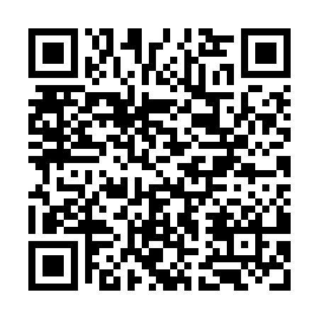
Prayer times for Elcho Island, Australia
Wed 1 May 2024 - Fri 31 May 2024
High Latitude Method: None
Prayer Calculation Method: Muslim World League
Asar Calculation Method: Shafi

Date | Day | Fajr | Sunrise | Dhuhr | Asr | Maghrib | Isha
1 | Wed | 5:21 | 6:34 | 12:24 | 3:44 | 6:14 | 7:22
2 | Thu | 5:21 | 6:34 | 12:24 | 3:44 | 6:14 | 7:22
3 | Fri | 5:22 | 6:34 | 12:24 | 3:44 | 6:14 | 7:22
4 | Sat | 5:22 | 6:34 | 12:24 | 3:44 | 6:13 | 7:22
5 | Sun | 5:22 | 6:34 | 12:24 | 3:44 | 6:13 | 7:21
6 | Mon | 5:22 | 6:34 | 12:24 | 3:44 | 6:13 | 7:21
7 | Tue | 5:22 | 6:35 | 12:24 | 3:43 | 6:12 | 7:21
8 | Wed | 5:22 | 6:35 | 12:24 | 3:43 | 6:12 | 7:21
9 | Thu | 5:22 | 6:35 | 12:23 | 3:43 | 6:12 | 7:21
10 | Fri | 5:22 | 6:35 | 12:23 | 3:43 | 6:11 | 7:20
11 | Sat | 5:22 | 6:35 | 12:23 | 3:43 | 6:11 | 7:20
12 | Sun | 5:22 | 6:36 | 12:23 | 3:43 | 6:11 | 7:20
13 | Mon | 5:22 | 6:36 | 12:23 | 3:43 | 6:11 | 7:20
14 | Tue | 5:23 | 6:36 | 12:23 | 3:43 | 6:11 | 7:20
15 | Wed | 5:23 | 6:36 | 12:23 | 3:42 | 6:10 | 7:20
16 | Thu | 5:23 | 6:37 | 12:23 | 3:42 | 6:10 | 7:20
17 | Fri | 5:23 | 6:37 | 12:23 | 3:42 | 6:10 | 7:20
18 | Sat | 5:23 | 6:37 | 12:23 | 3:42 | 6:10 | 7:19
19 | Sun | 5:23 | 6:37 | 12:24 | 3:42 | 6:10 | 7:19
20 | Mon | 5:23 | 6:38 | 12:24 | 3:42 | 6:09 | 7:19
21 | Tue | 5:24 | 6:38 | 12:24 | 3:42 | 6:09 | 7:19
22 | Wed | 5:24 | 6:38 | 12:24 | 3:42 | 6:09 | 7:19
23 | Thu | 5:24 | 6:38 | 12:24 | 3:42 | 6:09 | 7:19
24 | Fri | 5:24 | 6:39 | 12:24 | 3:42 | 6:09 | 7:19
25 | Sat | 5:24 | 6:39 | 12:24 | 3:42 | 6:09 | 7:19
26 | Sun | 5:24 | 6:39 | 12:24 | 3:42 | 6:09 | 7:19
27 | Mon | 5:25 | 6:39 | 12:24 | 3:42 | 6:09 | 7:19
28 | Tue | 5:25 | 6:40 | 12:24 | 3:42 | 6:09 | 7:19
29 | Wed | 5:25 | 6:40 | 12:24 | 3:42 | 6:09 | 7:19
30 | Thu | 5:25 | 6:40 | 12:25 | 3:42 | 6:09 | 7:20
31 | Fri | 5:25 | 6:41 | 12:25 | 3:42 | 6:09 | 7:20
Prayer times provided by https://www.salahtimes.com

