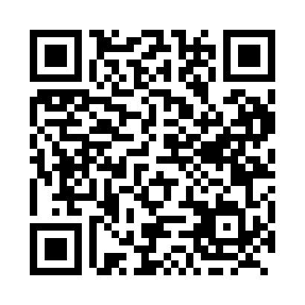
Prayer times for Knoxford, New Brunswick, Canada
Mon 1 Jul 2024 - Wed 31 Jul 2024
High Latitude Method: Angle Based Rule
Prayer Calculation Method: Islamic Society of North America
Asar Calculation Method: Hanafi

Date | Day | Fajr | Sunrise | Dhuhr | Asr | Maghrib | Isha
1 | Mon | 3:39 | 5:42 | 1:35 | 7:00 | 9:27 | 11:31
2 | Tue | 3:40 | 5:43 | 1:35 | 7:00 | 9:27 | 11:30
3 | Wed | 3:41 | 5:44 | 1:35 | 7:00 | 9:27 | 11:29
4 | Thu | 3:42 | 5:44 | 1:36 | 7:00 | 9:26 | 11:29
5 | Fri | 3:43 | 5:45 | 1:36 | 7:00 | 9:26 | 11:28
6 | Sat | 3:44 | 5:46 | 1:36 | 7:00 | 9:26 | 11:27
7 | Sun | 3:46 | 5:47 | 1:36 | 6:59 | 9:25 | 11:26
8 | Mon | 3:47 | 5:47 | 1:36 | 6:59 | 9:25 | 11:25
9 | Tue | 3:49 | 5:48 | 1:36 | 6:59 | 9:24 | 11:23
10 | Wed | 3:50 | 5:49 | 1:36 | 6:59 | 9:24 | 11:22
11 | Thu | 3:51 | 5:50 | 1:37 | 6:59 | 9:23 | 11:21
12 | Fri | 3:53 | 5:51 | 1:37 | 6:58 | 9:22 | 11:20
13 | Sat | 3:55 | 5:52 | 1:37 | 6:58 | 9:22 | 11:18
14 | Sun | 3:56 | 5:53 | 1:37 | 6:58 | 9:21 | 11:17
15 | Mon | 3:58 | 5:54 | 1:37 | 6:57 | 9:20 | 11:16
16 | Tue | 3:59 | 5:55 | 1:37 | 6:57 | 9:19 | 11:14
17 | Wed | 4:01 | 5:56 | 1:37 | 6:56 | 9:18 | 11:12
18 | Thu | 4:03 | 5:57 | 1:37 | 6:56 | 9:17 | 11:11
19 | Fri | 4:05 | 5:58 | 1:37 | 6:55 | 9:16 | 11:09
20 | Sat | 4:06 | 5:59 | 1:37 | 6:55 | 9:16 | 11:08
21 | Sun | 4:08 | 6:00 | 1:37 | 6:54 | 9:15 | 11:06
22 | Mon | 4:10 | 6:01 | 1:37 | 6:54 | 9:13 | 11:04
23 | Tue | 4:12 | 6:02 | 1:38 | 6:53 | 9:12 | 11:02
24 | Wed | 4:13 | 6:03 | 1:38 | 6:52 | 9:11 | 11:01
25 | Thu | 4:15 | 6:04 | 1:38 | 6:52 | 9:10 | 10:59
26 | Fri | 4:17 | 6:05 | 1:38 | 6:51 | 9:09 | 10:57
27 | Sat | 4:19 | 6:07 | 1:38 | 6:50 | 9:08 | 10:55
28 | Sun | 4:21 | 6:08 | 1:37 | 6:50 | 9:07 | 10:53
29 | Mon | 4:23 | 6:09 | 1:37 | 6:49 | 9:05 | 10:51
30 | Tue | 4:25 | 6:10 | 1:37 | 6:48 | 9:04 | 10:49
31 | Wed | 4:26 | 6:11 | 1:37 | 6:47 | 9:03 | 10:47
Prayer times provided by https://www.salahtimes.com

