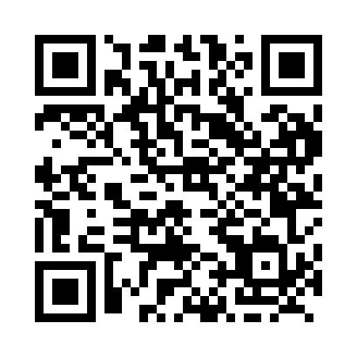
Prayer times for Doheny, Quebec, Canada
Mon 1 Apr 2024 - Tue 30 Apr 2024
High Latitude Method: Angle Based Rule
Prayer Calculation Method: Islamic Society of North America
Asar Calculation Method: Hanafi

Date | Day | Fajr | Sunrise | Dhuhr | Asr | Maghrib | Isha
1 | Mon | 5:02 | 6:28 | 12:54 | 5:23 | 7:21 | 8:48
2 | Tue | 4:59 | 6:26 | 12:54 | 5:24 | 7:22 | 8:49
3 | Wed | 4:57 | 6:24 | 12:53 | 5:25 | 7:23 | 8:51
4 | Thu | 4:55 | 6:22 | 12:53 | 5:26 | 7:25 | 8:53
5 | Fri | 4:53 | 6:21 | 12:53 | 5:27 | 7:26 | 8:54
6 | Sat | 4:50 | 6:19 | 12:53 | 5:28 | 7:27 | 8:56
7 | Sun | 4:48 | 6:17 | 12:52 | 5:29 | 7:29 | 8:58
8 | Mon | 4:46 | 6:15 | 12:52 | 5:30 | 7:30 | 8:59
9 | Tue | 4:43 | 6:13 | 12:52 | 5:31 | 7:32 | 9:01
10 | Wed | 4:41 | 6:11 | 12:52 | 5:32 | 7:33 | 9:03
11 | Thu | 4:39 | 6:09 | 12:51 | 5:33 | 7:34 | 9:05
12 | Fri | 4:37 | 6:07 | 12:51 | 5:34 | 7:36 | 9:07
13 | Sat | 4:34 | 6:05 | 12:51 | 5:34 | 7:37 | 9:08
14 | Sun | 4:32 | 6:03 | 12:51 | 5:35 | 7:39 | 9:10
15 | Mon | 4:30 | 6:01 | 12:50 | 5:36 | 7:40 | 9:12
16 | Tue | 4:27 | 6:00 | 12:50 | 5:37 | 7:41 | 9:14
17 | Wed | 4:25 | 5:58 | 12:50 | 5:38 | 7:43 | 9:16
18 | Thu | 4:23 | 5:56 | 12:50 | 5:39 | 7:44 | 9:17
19 | Fri | 4:21 | 5:54 | 12:49 | 5:40 | 7:45 | 9:19
20 | Sat | 4:18 | 5:52 | 12:49 | 5:41 | 7:47 | 9:21
21 | Sun | 4:16 | 5:51 | 12:49 | 5:42 | 7:48 | 9:23
22 | Mon | 4:14 | 5:49 | 12:49 | 5:42 | 7:50 | 9:25
23 | Tue | 4:12 | 5:47 | 12:49 | 5:43 | 7:51 | 9:27
24 | Wed | 4:09 | 5:45 | 12:48 | 5:44 | 7:52 | 9:29
25 | Thu | 4:07 | 5:44 | 12:48 | 5:45 | 7:54 | 9:31
26 | Fri | 4:05 | 5:42 | 12:48 | 5:46 | 7:55 | 9:33
27 | Sat | 4:03 | 5:40 | 12:48 | 5:47 | 7:56 | 9:34
28 | Sun | 4:00 | 5:39 | 12:48 | 5:48 | 7:58 | 9:36
29 | Mon | 3:58 | 5:37 | 12:48 | 5:48 | 7:59 | 9:38
30 | Tue | 3:56 | 5:35 | 12:48 | 5:49 | 8:01 | 9:40
Prayer times provided by https://www.salahtimes.com

