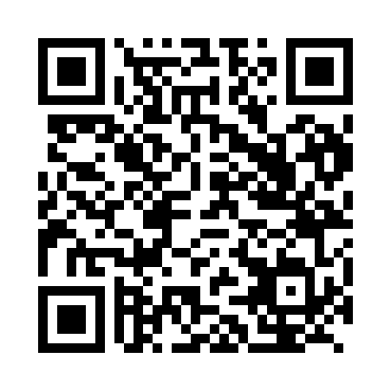
Prayer times for Bikoki, Cameroon
Wed 1 May 2024 - Fri 31 May 2024
High Latitude Method: None
Prayer Calculation Method: Muslim World League
Asar Calculation Method: Shafi

Date | Day | Fajr | Sunrise | Dhuhr | Asr | Maghrib | Isha
1 | Wed | 4:59 | 6:11 | 12:20 | 3:38 | 6:29 | 7:36
2 | Thu | 4:59 | 6:11 | 12:20 | 3:39 | 6:29 | 7:36
3 | Fri | 4:59 | 6:11 | 12:20 | 3:39 | 6:29 | 7:36
4 | Sat | 4:58 | 6:11 | 12:20 | 3:39 | 6:29 | 7:37
5 | Sun | 4:58 | 6:10 | 12:20 | 3:40 | 6:29 | 7:37
6 | Mon | 4:58 | 6:10 | 12:19 | 3:40 | 6:29 | 7:37
7 | Tue | 4:58 | 6:10 | 12:19 | 3:40 | 6:29 | 7:37
8 | Wed | 4:57 | 6:10 | 12:19 | 3:40 | 6:29 | 7:37
9 | Thu | 4:57 | 6:10 | 12:19 | 3:41 | 6:29 | 7:37
10 | Fri | 4:57 | 6:10 | 12:19 | 3:41 | 6:29 | 7:38
11 | Sat | 4:57 | 6:10 | 12:19 | 3:41 | 6:29 | 7:38
12 | Sun | 4:56 | 6:09 | 12:19 | 3:41 | 6:29 | 7:38
13 | Mon | 4:56 | 6:09 | 12:19 | 3:42 | 6:29 | 7:38
14 | Tue | 4:56 | 6:09 | 12:19 | 3:42 | 6:29 | 7:38
15 | Wed | 4:56 | 6:09 | 12:19 | 3:42 | 6:29 | 7:39
16 | Thu | 4:56 | 6:09 | 12:19 | 3:42 | 6:29 | 7:39
17 | Fri | 4:55 | 6:09 | 12:19 | 3:43 | 6:30 | 7:39
18 | Sat | 4:55 | 6:09 | 12:19 | 3:43 | 6:30 | 7:39
19 | Sun | 4:55 | 6:09 | 12:19 | 3:43 | 6:30 | 7:39
20 | Mon | 4:55 | 6:09 | 12:19 | 3:44 | 6:30 | 7:40
21 | Tue | 4:55 | 6:09 | 12:20 | 3:44 | 6:30 | 7:40
22 | Wed | 4:55 | 6:09 | 12:20 | 3:44 | 6:30 | 7:40
23 | Thu | 4:55 | 6:09 | 12:20 | 3:44 | 6:30 | 7:40
24 | Fri | 4:54 | 6:09 | 12:20 | 3:45 | 6:31 | 7:41
25 | Sat | 4:54 | 6:09 | 12:20 | 3:45 | 6:31 | 7:41
26 | Sun | 4:54 | 6:09 | 12:20 | 3:45 | 6:31 | 7:41
27 | Mon | 4:54 | 6:09 | 12:20 | 3:45 | 6:31 | 7:42
28 | Tue | 4:54 | 6:09 | 12:20 | 3:46 | 6:31 | 7:42
29 | Wed | 4:54 | 6:09 | 12:20 | 3:46 | 6:32 | 7:42
30 | Thu | 4:54 | 6:09 | 12:20 | 3:46 | 6:32 | 7:42
31 | Fri | 4:54 | 6:09 | 12:21 | 3:47 | 6:32 | 7:43
Prayer times provided by https://www.salahtimes.com

