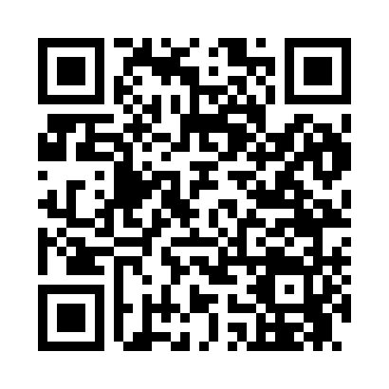
Prayer times for Coronado, California, USA
Mon 1 Apr 2024 - Tue 30 Apr 2024
High Latitude Method: Angle Based Rule
Prayer Calculation Method: Islamic Society of North America
Asar Calculation Method: Shafi

Date | Day | Fajr | Sunrise | Dhuhr | Asr | Maghrib | Isha
1 | Mon | 5:27 | 6:36 | 12:52 | 4:25 | 7:09 | 8:18
2 | Tue | 5:26 | 6:35 | 12:52 | 4:26 | 7:10 | 8:19
3 | Wed | 5:24 | 6:33 | 12:52 | 4:26 | 7:11 | 8:20
4 | Thu | 5:23 | 6:32 | 12:51 | 4:26 | 7:11 | 8:21
5 | Fri | 5:22 | 6:31 | 12:51 | 4:26 | 7:12 | 8:21
6 | Sat | 5:20 | 6:30 | 12:51 | 4:26 | 7:13 | 8:22
7 | Sun | 5:19 | 6:28 | 12:51 | 4:26 | 7:14 | 8:23
8 | Mon | 5:17 | 6:27 | 12:50 | 4:26 | 7:14 | 8:24
9 | Tue | 5:16 | 6:26 | 12:50 | 4:26 | 7:15 | 8:25
10 | Wed | 5:15 | 6:24 | 12:50 | 4:26 | 7:16 | 8:26
11 | Thu | 5:13 | 6:23 | 12:50 | 4:26 | 7:16 | 8:26
12 | Fri | 5:12 | 6:22 | 12:49 | 4:26 | 7:17 | 8:27
13 | Sat | 5:11 | 6:21 | 12:49 | 4:26 | 7:18 | 8:28
14 | Sun | 5:09 | 6:20 | 12:49 | 4:26 | 7:19 | 8:29
15 | Mon | 5:08 | 6:18 | 12:49 | 4:26 | 7:19 | 8:30
16 | Tue | 5:06 | 6:17 | 12:48 | 4:26 | 7:20 | 8:31
17 | Wed | 5:05 | 6:16 | 12:48 | 4:26 | 7:21 | 8:32
18 | Thu | 5:04 | 6:15 | 12:48 | 4:26 | 7:21 | 8:33
19 | Fri | 5:02 | 6:14 | 12:48 | 4:26 | 7:22 | 8:34
20 | Sat | 5:01 | 6:13 | 12:47 | 4:26 | 7:23 | 8:35
21 | Sun | 5:00 | 6:11 | 12:47 | 4:26 | 7:24 | 8:35
22 | Mon | 4:58 | 6:10 | 12:47 | 4:26 | 7:24 | 8:36
23 | Tue | 4:57 | 6:09 | 12:47 | 4:26 | 7:25 | 8:37
24 | Wed | 4:56 | 6:08 | 12:47 | 4:26 | 7:26 | 8:38
25 | Thu | 4:55 | 6:07 | 12:47 | 4:26 | 7:26 | 8:39
26 | Fri | 4:53 | 6:06 | 12:46 | 4:27 | 7:27 | 8:40
27 | Sat | 4:52 | 6:05 | 12:46 | 4:27 | 7:28 | 8:41
28 | Sun | 4:51 | 6:04 | 12:46 | 4:27 | 7:29 | 8:42
29 | Mon | 4:50 | 6:03 | 12:46 | 4:27 | 7:29 | 8:43
30 | Tue | 4:48 | 6:02 | 12:46 | 4:27 | 7:30 | 8:44
Prayer times provided by https://www.salahtimes.com

