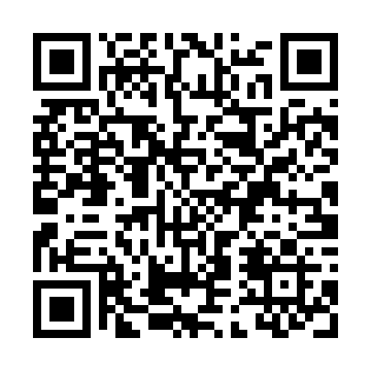
Prayer times for Champ-Florentin, France
Wed 1 May 2024 - Fri 31 May 2024
High Latitude Method: Angle Based Rule
Prayer Calculation Method: Islamic Organisations Union of France
Asar Calculation Method: Shafi

Date | Day | Fajr | Sunrise | Dhuhr | Asr | Maghrib | Isha
1 | Wed | 5:21 | 6:37 | 1:49 | 5:47 | 9:02 | 10:18
2 | Thu | 5:19 | 6:35 | 1:49 | 5:48 | 9:03 | 10:19
3 | Fri | 5:18 | 6:34 | 1:49 | 5:48 | 9:04 | 10:21
4 | Sat | 5:16 | 6:32 | 1:49 | 5:48 | 9:06 | 10:23
5 | Sun | 5:14 | 6:31 | 1:49 | 5:49 | 9:07 | 10:25
6 | Mon | 5:12 | 6:29 | 1:49 | 5:49 | 9:08 | 10:26
7 | Tue | 5:10 | 6:28 | 1:49 | 5:50 | 9:10 | 10:28
8 | Wed | 5:08 | 6:27 | 1:48 | 5:50 | 9:11 | 10:30
9 | Thu | 5:06 | 6:25 | 1:48 | 5:51 | 9:12 | 10:31
10 | Fri | 5:05 | 6:24 | 1:48 | 5:51 | 9:14 | 10:33
11 | Sat | 5:03 | 6:23 | 1:48 | 5:52 | 9:15 | 10:35
12 | Sun | 5:01 | 6:21 | 1:48 | 5:52 | 9:16 | 10:37
13 | Mon | 4:59 | 6:20 | 1:48 | 5:53 | 9:17 | 10:38
14 | Tue | 4:58 | 6:19 | 1:48 | 5:53 | 9:19 | 10:40
15 | Wed | 4:56 | 6:18 | 1:48 | 5:53 | 9:20 | 10:42
16 | Thu | 4:54 | 6:16 | 1:48 | 5:54 | 9:21 | 10:43
17 | Fri | 4:53 | 6:15 | 1:48 | 5:54 | 9:22 | 10:45
18 | Sat | 4:51 | 6:14 | 1:48 | 5:55 | 9:23 | 10:46
19 | Sun | 4:50 | 6:13 | 1:49 | 5:55 | 9:24 | 10:48
20 | Mon | 4:48 | 6:12 | 1:49 | 5:56 | 9:26 | 10:50
21 | Tue | 4:47 | 6:11 | 1:49 | 5:56 | 9:27 | 10:51
22 | Wed | 4:45 | 6:10 | 1:49 | 5:56 | 9:28 | 10:53
23 | Thu | 4:44 | 6:09 | 1:49 | 5:57 | 9:29 | 10:54
24 | Fri | 4:43 | 6:08 | 1:49 | 5:57 | 9:30 | 10:56
25 | Sat | 4:41 | 6:07 | 1:49 | 5:58 | 9:31 | 10:57
26 | Sun | 4:40 | 6:07 | 1:49 | 5:58 | 9:32 | 10:59
27 | Mon | 4:39 | 6:06 | 1:49 | 5:58 | 9:33 | 11:00
28 | Tue | 4:38 | 6:05 | 1:49 | 5:59 | 9:34 | 11:02
29 | Wed | 4:37 | 6:04 | 1:49 | 5:59 | 9:35 | 11:03
30 | Thu | 4:36 | 6:04 | 1:50 | 6:00 | 9:36 | 11:04
31 | Fri | 4:35 | 6:03 | 1:50 | 6:00 | 9:37 | 11:06
Prayer times provided by https://www.salahtimes.com

