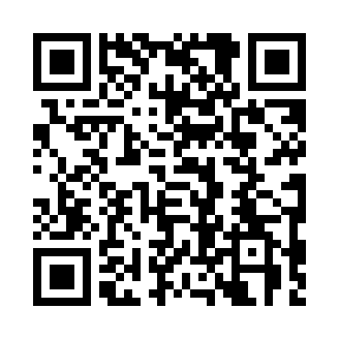
Prayer times for Ullasautik, Quebec, Canada
Wed 1 May 2024 - Fri 31 May 2024
High Latitude Method: Angle Based Rule
Prayer Calculation Method: Islamic Society of North America
Asar Calculation Method: Hanafi

Date | Day | Fajr | Sunrise | Dhuhr | Asr | Maghrib | Isha
1 | Wed | 2:36 | 4:35 | 12:36 | 5:54 | 8:37 | 10:37
2 | Thu | 2:34 | 4:33 | 12:36 | 5:55 | 8:40 | 10:38
3 | Fri | 2:33 | 4:30 | 12:35 | 5:56 | 8:42 | 10:39
4 | Sat | 2:32 | 4:27 | 12:35 | 5:58 | 8:45 | 10:40
5 | Sun | 2:30 | 4:25 | 12:35 | 5:59 | 8:47 | 10:42
6 | Mon | 2:29 | 4:22 | 12:35 | 6:01 | 8:50 | 10:43
7 | Tue | 2:28 | 4:20 | 12:35 | 6:02 | 8:52 | 10:44
8 | Wed | 2:26 | 4:17 | 12:35 | 6:03 | 8:55 | 10:45
9 | Thu | 2:25 | 4:15 | 12:35 | 6:05 | 8:57 | 10:46
10 | Fri | 2:24 | 4:12 | 12:35 | 6:06 | 8:59 | 10:48
11 | Sat | 2:23 | 4:10 | 12:35 | 6:07 | 9:02 | 10:49
12 | Sun | 2:21 | 4:07 | 12:35 | 6:09 | 9:04 | 10:50
13 | Mon | 2:20 | 4:05 | 12:35 | 6:10 | 9:06 | 10:51
14 | Tue | 2:19 | 4:02 | 12:35 | 6:11 | 9:09 | 10:52
15 | Wed | 2:18 | 4:00 | 12:35 | 6:12 | 9:11 | 10:53
16 | Thu | 2:17 | 3:58 | 12:35 | 6:14 | 9:13 | 10:55
17 | Fri | 2:16 | 3:56 | 12:35 | 6:15 | 9:16 | 10:56
18 | Sat | 2:15 | 3:53 | 12:35 | 6:16 | 9:18 | 10:57
19 | Sun | 2:14 | 3:51 | 12:35 | 6:17 | 9:20 | 10:58
20 | Mon | 2:12 | 3:49 | 12:35 | 6:18 | 9:22 | 10:59
21 | Tue | 2:11 | 3:47 | 12:35 | 6:20 | 9:25 | 11:00
22 | Wed | 2:11 | 3:45 | 12:35 | 6:21 | 9:27 | 11:01
23 | Thu | 2:10 | 3:43 | 12:36 | 6:22 | 9:29 | 11:02
24 | Fri | 2:09 | 3:41 | 12:36 | 6:23 | 9:31 | 11:04
25 | Sat | 2:08 | 3:39 | 12:36 | 6:24 | 9:33 | 11:05
26 | Sun | 2:07 | 3:38 | 12:36 | 6:25 | 9:35 | 11:06
27 | Mon | 2:06 | 3:36 | 12:36 | 6:26 | 9:37 | 11:07
28 | Tue | 2:05 | 3:34 | 12:36 | 6:27 | 9:39 | 11:08
29 | Wed | 2:05 | 3:32 | 12:36 | 6:28 | 9:41 | 11:09
30 | Thu | 2:04 | 3:31 | 12:36 | 6:29 | 9:43 | 11:10
31 | Fri | 2:03 | 3:29 | 12:36 | 6:30 | 9:44 | 11:11
Prayer times provided by https://www.salahtimes.com

