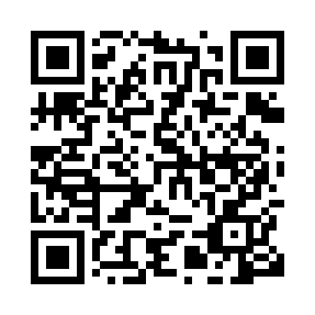
Prayer times for Melinka, Chile
Wed 1 May 2024 - Fri 31 May 2024
High Latitude Method: None
Prayer Calculation Method: Muslim World League
Asar Calculation Method: Shafi

Date | Day | Fajr | Sunrise | Dhuhr | Asr | Maghrib | Isha
1 | Wed | 6:10 | 7:48 | 12:52 | 3:31 | 5:55 | 7:28
2 | Thu | 6:11 | 7:49 | 12:52 | 3:30 | 5:54 | 7:26
3 | Fri | 6:12 | 7:50 | 12:52 | 3:29 | 5:53 | 7:25
4 | Sat | 6:13 | 7:51 | 12:52 | 3:28 | 5:51 | 7:24
5 | Sun | 6:14 | 7:53 | 12:52 | 3:27 | 5:50 | 7:23
6 | Mon | 6:15 | 7:54 | 12:52 | 3:26 | 5:49 | 7:22
7 | Tue | 6:16 | 7:55 | 12:51 | 3:25 | 5:47 | 7:21
8 | Wed | 6:17 | 7:56 | 12:51 | 3:24 | 5:46 | 7:20
9 | Thu | 6:18 | 7:57 | 12:51 | 3:23 | 5:45 | 7:19
10 | Fri | 6:19 | 7:58 | 12:51 | 3:22 | 5:44 | 7:18
11 | Sat | 6:20 | 7:59 | 12:51 | 3:21 | 5:43 | 7:17
12 | Sun | 6:21 | 8:00 | 12:51 | 3:20 | 5:42 | 7:16
13 | Mon | 6:22 | 8:02 | 12:51 | 3:19 | 5:41 | 7:15
14 | Tue | 6:22 | 8:03 | 12:51 | 3:19 | 5:39 | 7:14
15 | Wed | 6:23 | 8:04 | 12:51 | 3:18 | 5:38 | 7:13
16 | Thu | 6:24 | 8:05 | 12:51 | 3:17 | 5:37 | 7:12
17 | Fri | 6:25 | 8:06 | 12:51 | 3:16 | 5:36 | 7:12
18 | Sat | 6:26 | 8:07 | 12:51 | 3:15 | 5:36 | 7:11
19 | Sun | 6:27 | 8:08 | 12:51 | 3:15 | 5:35 | 7:10
20 | Mon | 6:28 | 8:09 | 12:52 | 3:14 | 5:34 | 7:09
21 | Tue | 6:28 | 8:10 | 12:52 | 3:13 | 5:33 | 7:09
22 | Wed | 6:29 | 8:11 | 12:52 | 3:13 | 5:32 | 7:08
23 | Thu | 6:30 | 8:12 | 12:52 | 3:12 | 5:31 | 7:07
24 | Fri | 6:31 | 8:13 | 12:52 | 3:11 | 5:31 | 7:07
25 | Sat | 6:32 | 8:14 | 12:52 | 3:11 | 5:30 | 7:06
26 | Sun | 6:32 | 8:15 | 12:52 | 3:10 | 5:29 | 7:06
27 | Mon | 6:33 | 8:15 | 12:52 | 3:10 | 5:29 | 7:05
28 | Tue | 6:34 | 8:16 | 12:52 | 3:09 | 5:28 | 7:05
29 | Wed | 6:34 | 8:17 | 12:52 | 3:09 | 5:27 | 7:04
30 | Thu | 6:35 | 8:18 | 12:53 | 3:08 | 5:27 | 7:04
31 | Fri | 6:36 | 8:19 | 12:53 | 3:08 | 5:26 | 7:04
Prayer times provided by https://www.salahtimes.com

