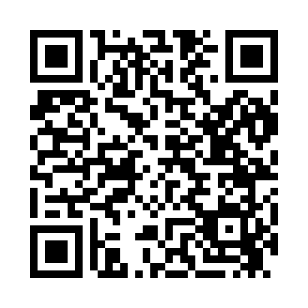
Prayer times for Camp Travis, Illinois, USA
Mon 1 Jul 2024 - Wed 31 Jul 2024
High Latitude Method: Angle Based Rule
Prayer Calculation Method: Islamic Society of North America
Asar Calculation Method: Shafi

Date | Day | Fajr | Sunrise | Dhuhr | Asr | Maghrib | Isha
1 | Mon | 3:59 | 5:33 | 12:57 | 4:53 | 8:22 | 9:55
2 | Tue | 4:00 | 5:33 | 12:58 | 4:53 | 8:22 | 9:55
3 | Wed | 4:01 | 5:34 | 12:58 | 4:53 | 8:22 | 9:54
4 | Thu | 4:01 | 5:34 | 12:58 | 4:53 | 8:21 | 9:54
5 | Fri | 4:02 | 5:35 | 12:58 | 4:53 | 8:21 | 9:54
6 | Sat | 4:03 | 5:35 | 12:58 | 4:54 | 8:21 | 9:53
7 | Sun | 4:04 | 5:36 | 12:58 | 4:54 | 8:21 | 9:53
8 | Mon | 4:05 | 5:37 | 12:59 | 4:54 | 8:20 | 9:52
9 | Tue | 4:06 | 5:37 | 12:59 | 4:54 | 8:20 | 9:51
10 | Wed | 4:06 | 5:38 | 12:59 | 4:54 | 8:19 | 9:51
11 | Thu | 4:07 | 5:39 | 12:59 | 4:54 | 8:19 | 9:50
12 | Fri | 4:08 | 5:39 | 12:59 | 4:54 | 8:19 | 9:49
13 | Sat | 4:09 | 5:40 | 12:59 | 4:54 | 8:18 | 9:49
14 | Sun | 4:10 | 5:41 | 12:59 | 4:54 | 8:18 | 9:48
15 | Mon | 4:11 | 5:41 | 12:59 | 4:54 | 8:17 | 9:47
16 | Tue | 4:12 | 5:42 | 12:59 | 4:54 | 8:16 | 9:46
17 | Wed | 4:13 | 5:43 | 1:00 | 4:54 | 8:16 | 9:45
18 | Thu | 4:14 | 5:44 | 1:00 | 4:54 | 8:15 | 9:44
19 | Fri | 4:15 | 5:45 | 1:00 | 4:54 | 8:15 | 9:43
20 | Sat | 4:17 | 5:45 | 1:00 | 4:54 | 8:14 | 9:42
21 | Sun | 4:18 | 5:46 | 1:00 | 4:53 | 8:13 | 9:41
22 | Mon | 4:19 | 5:47 | 1:00 | 4:53 | 8:12 | 9:40
23 | Tue | 4:20 | 5:48 | 1:00 | 4:53 | 8:12 | 9:39
24 | Wed | 4:21 | 5:49 | 1:00 | 4:53 | 8:11 | 9:38
25 | Thu | 4:22 | 5:49 | 1:00 | 4:53 | 8:10 | 9:37
26 | Fri | 4:23 | 5:50 | 1:00 | 4:53 | 8:09 | 9:36
27 | Sat | 4:25 | 5:51 | 1:00 | 4:52 | 8:08 | 9:34
28 | Sun | 4:26 | 5:52 | 1:00 | 4:52 | 8:07 | 9:33
29 | Mon | 4:27 | 5:53 | 1:00 | 4:52 | 8:06 | 9:32
30 | Tue | 4:28 | 5:54 | 1:00 | 4:52 | 8:05 | 9:31
31 | Wed | 4:29 | 5:55 | 1:00 | 4:51 | 8:04 | 9:29
Prayer times provided by https://www.salahtimes.com

