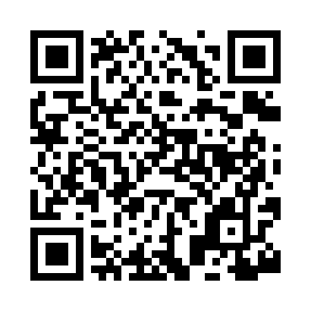
Prayer times for Beckwith, Iowa, USA
Wed 1 May 2024 - Fri 31 May 2024
High Latitude Method: Angle Based Rule
Prayer Calculation Method: Islamic Society of North America
Asar Calculation Method: Shafi

Date | Day | Fajr | Sunrise | Dhuhr | Asr | Maghrib | Isha
1 | Wed | 4:39 | 6:05 | 1:04 | 4:56 | 8:05 | 9:31
2 | Thu | 4:37 | 6:03 | 1:04 | 4:57 | 8:06 | 9:32
3 | Fri | 4:36 | 6:02 | 1:04 | 4:57 | 8:07 | 9:34
4 | Sat | 4:34 | 6:01 | 1:04 | 4:57 | 8:08 | 9:35
5 | Sun | 4:32 | 6:00 | 1:04 | 4:58 | 8:09 | 9:37
6 | Mon | 4:31 | 5:59 | 1:04 | 4:58 | 8:10 | 9:38
7 | Tue | 4:29 | 5:57 | 1:04 | 4:58 | 8:11 | 9:39
8 | Wed | 4:28 | 5:56 | 1:04 | 4:58 | 8:12 | 9:41
9 | Thu | 4:26 | 5:55 | 1:04 | 4:59 | 8:13 | 9:42
10 | Fri | 4:25 | 5:54 | 1:04 | 4:59 | 8:14 | 9:44
11 | Sat | 4:23 | 5:53 | 1:04 | 4:59 | 8:15 | 9:45
12 | Sun | 4:22 | 5:52 | 1:04 | 5:00 | 8:16 | 9:47
13 | Mon | 4:20 | 5:51 | 1:04 | 5:00 | 8:17 | 9:48
14 | Tue | 4:19 | 5:50 | 1:04 | 5:00 | 8:18 | 9:49
15 | Wed | 4:18 | 5:49 | 1:04 | 5:00 | 8:19 | 9:51
16 | Thu | 4:16 | 5:48 | 1:04 | 5:01 | 8:20 | 9:52
17 | Fri | 4:15 | 5:47 | 1:04 | 5:01 | 8:21 | 9:53
18 | Sat | 4:14 | 5:46 | 1:04 | 5:01 | 8:22 | 9:55
19 | Sun | 4:13 | 5:45 | 1:04 | 5:01 | 8:23 | 9:56
20 | Mon | 4:11 | 5:45 | 1:04 | 5:02 | 8:24 | 9:57
21 | Tue | 4:10 | 5:44 | 1:04 | 5:02 | 8:25 | 9:59
22 | Wed | 4:09 | 5:43 | 1:04 | 5:02 | 8:26 | 10:00
23 | Thu | 4:08 | 5:42 | 1:04 | 5:03 | 8:27 | 10:01
24 | Fri | 4:07 | 5:42 | 1:04 | 5:03 | 8:27 | 10:02
25 | Sat | 4:06 | 5:41 | 1:04 | 5:03 | 8:28 | 10:04
26 | Sun | 4:05 | 5:40 | 1:05 | 5:03 | 8:29 | 10:05
27 | Mon | 4:04 | 5:40 | 1:05 | 5:04 | 8:30 | 10:06
28 | Tue | 4:03 | 5:39 | 1:05 | 5:04 | 8:31 | 10:07
29 | Wed | 4:02 | 5:39 | 1:05 | 5:04 | 8:32 | 10:08
30 | Thu | 4:01 | 5:38 | 1:05 | 5:05 | 8:32 | 10:09
31 | Fri | 4:00 | 5:38 | 1:05 | 5:05 | 8:33 | 10:11
Prayer times provided by https://www.salahtimes.com

