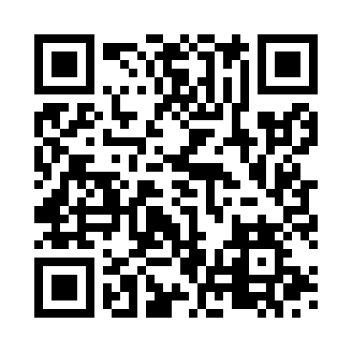
Prayer times for Monaco, Monaco
Wed 1 May 2024 - Fri 31 May 2024
High Latitude Method: None
Prayer Calculation Method: Muslim World League
Asar Calculation Method: Shafi

Date | Day | Fajr | Sunrise | Dhuhr | Asr | Maghrib | Isha
1 | Wed | 4:29 | 6:22 | 1:27 | 5:22 | 8:33 | 10:20
2 | Thu | 4:27 | 6:21 | 1:27 | 5:23 | 8:35 | 10:21
3 | Fri | 4:25 | 6:19 | 1:27 | 5:23 | 8:36 | 10:23
4 | Sat | 4:23 | 6:18 | 1:27 | 5:23 | 8:37 | 10:25
5 | Sun | 4:21 | 6:17 | 1:27 | 5:24 | 8:38 | 10:27
6 | Mon | 4:19 | 6:15 | 1:27 | 5:24 | 8:39 | 10:28
7 | Tue | 4:17 | 6:14 | 1:27 | 5:25 | 8:40 | 10:30
8 | Wed | 4:15 | 6:13 | 1:27 | 5:25 | 8:41 | 10:32
9 | Thu | 4:13 | 6:12 | 1:27 | 5:25 | 8:43 | 10:34
10 | Fri | 4:11 | 6:10 | 1:27 | 5:26 | 8:44 | 10:35
11 | Sat | 4:09 | 6:09 | 1:27 | 5:26 | 8:45 | 10:37
12 | Sun | 4:07 | 6:08 | 1:27 | 5:26 | 8:46 | 10:39
13 | Mon | 4:05 | 6:07 | 1:27 | 5:27 | 8:47 | 10:41
14 | Tue | 4:03 | 6:06 | 1:27 | 5:27 | 8:48 | 10:43
15 | Wed | 4:01 | 6:05 | 1:27 | 5:27 | 8:49 | 10:44
16 | Thu | 4:00 | 6:04 | 1:27 | 5:28 | 8:50 | 10:46
17 | Fri | 3:58 | 6:03 | 1:27 | 5:28 | 8:51 | 10:48
18 | Sat | 3:56 | 6:02 | 1:27 | 5:29 | 8:52 | 10:49
19 | Sun | 3:54 | 6:01 | 1:27 | 5:29 | 8:53 | 10:51
20 | Mon | 3:53 | 6:00 | 1:27 | 5:29 | 8:55 | 10:53
21 | Tue | 3:51 | 5:59 | 1:27 | 5:30 | 8:56 | 10:55
22 | Wed | 3:49 | 5:58 | 1:27 | 5:30 | 8:57 | 10:56
23 | Thu | 3:48 | 5:57 | 1:27 | 5:30 | 8:58 | 10:58
24 | Fri | 3:46 | 5:56 | 1:27 | 5:31 | 8:58 | 10:59
25 | Sat | 3:45 | 5:56 | 1:27 | 5:31 | 8:59 | 11:01
26 | Sun | 3:43 | 5:55 | 1:27 | 5:31 | 9:00 | 11:03
27 | Mon | 3:42 | 5:54 | 1:28 | 5:32 | 9:01 | 11:04
28 | Tue | 3:40 | 5:54 | 1:28 | 5:32 | 9:02 | 11:06
29 | Wed | 3:39 | 5:53 | 1:28 | 5:32 | 9:03 | 11:07
30 | Thu | 3:38 | 5:52 | 1:28 | 5:33 | 9:04 | 11:09
31 | Fri | 3:37 | 5:52 | 1:28 | 5:33 | 9:05 | 11:10
Prayer times provided by https://www.salahtimes.com

