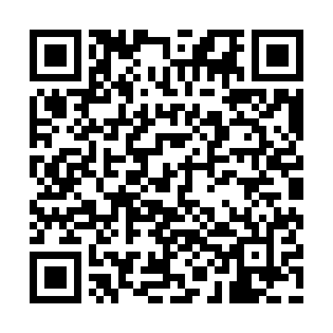
Prayer times for Khemis Miliana, Algeria
Mon 1 Apr 2024 - Tue 30 Apr 2024
High Latitude Method: None
Prayer Calculation Method: Algerian Ministry of Religious Affairs and Wakfs
Asar Calculation Method: Shafi

Date | Day | Fajr | Sunrise | Dhuhr | Asr | Maghrib | Isha
1 | Mon | 5:09 | 6:37 | 12:55 | 4:29 | 7:13 | 8:36
2 | Tue | 5:08 | 6:35 | 12:55 | 4:29 | 7:14 | 8:37
3 | Wed | 5:06 | 6:34 | 12:54 | 4:29 | 7:15 | 8:38
4 | Thu | 5:04 | 6:33 | 12:54 | 4:30 | 7:16 | 8:39
5 | Fri | 5:03 | 6:31 | 12:54 | 4:30 | 7:17 | 8:40
6 | Sat | 5:01 | 6:30 | 12:53 | 4:30 | 7:18 | 8:41
7 | Sun | 4:59 | 6:28 | 12:53 | 4:30 | 7:19 | 8:42
8 | Mon | 4:58 | 6:27 | 12:53 | 4:31 | 7:19 | 8:43
9 | Tue | 4:56 | 6:25 | 12:53 | 4:31 | 7:20 | 8:44
10 | Wed | 4:55 | 6:24 | 12:52 | 4:31 | 7:21 | 8:45
11 | Thu | 4:53 | 6:23 | 12:52 | 4:31 | 7:22 | 8:46
12 | Fri | 4:51 | 6:21 | 12:52 | 4:31 | 7:23 | 8:48
13 | Sat | 4:50 | 6:20 | 12:52 | 4:31 | 7:24 | 8:49
14 | Sun | 4:48 | 6:19 | 12:51 | 4:32 | 7:25 | 8:50
15 | Mon | 4:46 | 6:17 | 12:51 | 4:32 | 7:25 | 8:51
16 | Tue | 4:45 | 6:16 | 12:51 | 4:32 | 7:26 | 8:52
17 | Wed | 4:43 | 6:15 | 12:51 | 4:32 | 7:27 | 8:53
18 | Thu | 4:42 | 6:13 | 12:50 | 4:32 | 7:28 | 8:54
19 | Fri | 4:40 | 6:12 | 12:50 | 4:32 | 7:29 | 8:55
20 | Sat | 4:38 | 6:11 | 12:50 | 4:32 | 7:30 | 8:56
21 | Sun | 4:37 | 6:10 | 12:50 | 4:33 | 7:30 | 8:58
22 | Mon | 4:35 | 6:08 | 12:50 | 4:33 | 7:31 | 8:59
23 | Tue | 4:34 | 6:07 | 12:49 | 4:33 | 7:32 | 9:00
24 | Wed | 4:32 | 6:06 | 12:49 | 4:33 | 7:33 | 9:01
25 | Thu | 4:31 | 6:05 | 12:49 | 4:33 | 7:34 | 9:02
26 | Fri | 4:29 | 6:03 | 12:49 | 4:33 | 7:35 | 9:03
27 | Sat | 4:28 | 6:02 | 12:49 | 4:33 | 7:36 | 9:05
28 | Sun | 4:26 | 6:01 | 12:49 | 4:34 | 7:37 | 9:06
29 | Mon | 4:25 | 6:00 | 12:48 | 4:34 | 7:37 | 9:07
30 | Tue | 4:23 | 5:59 | 12:48 | 4:34 | 7:38 | 9:08
Prayer times provided by https://www.salahtimes.com

