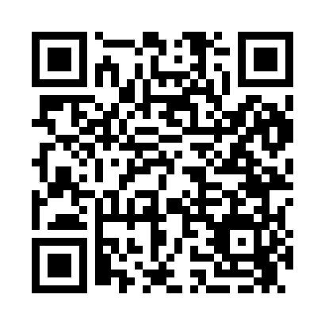
Prayer times for Bright, Arkansas, USA
Mon 1 Jul 2024 - Wed 31 Jul 2024
High Latitude Method: Angle Based Rule
Prayer Calculation Method: Islamic Society of North America
Asar Calculation Method: Shafi

Date | Day | Fajr | Sunrise | Dhuhr | Asr | Maghrib | Isha
1 | Mon | 4:45 | 6:08 | 1:17 | 5:01 | 8:27 | 9:50
2 | Tue | 4:45 | 6:08 | 1:18 | 5:01 | 8:27 | 9:50
3 | Wed | 4:46 | 6:08 | 1:18 | 5:02 | 8:27 | 9:49
4 | Thu | 4:46 | 6:09 | 1:18 | 5:02 | 8:27 | 9:49
5 | Fri | 4:47 | 6:09 | 1:18 | 5:02 | 8:27 | 9:49
6 | Sat | 4:48 | 6:10 | 1:18 | 5:02 | 8:26 | 9:49
7 | Sun | 4:48 | 6:10 | 1:18 | 5:02 | 8:26 | 9:48
8 | Mon | 4:49 | 6:11 | 1:19 | 5:02 | 8:26 | 9:48
9 | Tue | 4:50 | 6:11 | 1:19 | 5:02 | 8:26 | 9:47
10 | Wed | 4:50 | 6:12 | 1:19 | 5:03 | 8:25 | 9:47
11 | Thu | 4:51 | 6:13 | 1:19 | 5:03 | 8:25 | 9:46
12 | Fri | 4:52 | 6:13 | 1:19 | 5:03 | 8:25 | 9:46
13 | Sat | 4:53 | 6:14 | 1:19 | 5:03 | 8:24 | 9:45
14 | Sun | 4:53 | 6:14 | 1:19 | 5:03 | 8:24 | 9:45
15 | Mon | 4:54 | 6:15 | 1:19 | 5:03 | 8:23 | 9:44
16 | Tue | 4:55 | 6:16 | 1:19 | 5:03 | 8:23 | 9:43
17 | Wed | 4:56 | 6:16 | 1:20 | 5:03 | 8:23 | 9:43
18 | Thu | 4:57 | 6:17 | 1:20 | 5:03 | 8:22 | 9:42
19 | Fri | 4:58 | 6:17 | 1:20 | 5:03 | 8:22 | 9:41
20 | Sat | 4:58 | 6:18 | 1:20 | 5:03 | 8:21 | 9:41
21 | Sun | 4:59 | 6:19 | 1:20 | 5:03 | 8:20 | 9:40
22 | Mon | 5:00 | 6:19 | 1:20 | 5:03 | 8:20 | 9:39
23 | Tue | 5:01 | 6:20 | 1:20 | 5:03 | 8:19 | 9:38
24 | Wed | 5:02 | 6:21 | 1:20 | 5:03 | 8:19 | 9:37
25 | Thu | 5:03 | 6:21 | 1:20 | 5:03 | 8:18 | 9:36
26 | Fri | 5:04 | 6:22 | 1:20 | 5:03 | 8:17 | 9:35
27 | Sat | 5:05 | 6:23 | 1:20 | 5:03 | 8:16 | 9:34
28 | Sun | 5:06 | 6:24 | 1:20 | 5:03 | 8:16 | 9:33
29 | Mon | 5:07 | 6:24 | 1:20 | 5:03 | 8:15 | 9:32
30 | Tue | 5:08 | 6:25 | 1:20 | 5:03 | 8:14 | 9:31
31 | Wed | 5:09 | 6:26 | 1:20 | 5:03 | 8:13 | 9:30
Prayer times provided by https://www.salahtimes.com

