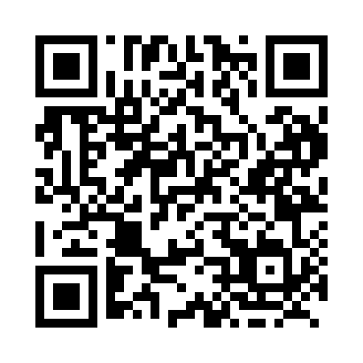
Prayer times for Atik, Manitoba, Canada
Wed 1 May 2024 - Fri 31 May 2024
High Latitude Method: Angle Based Rule
Prayer Calculation Method: Islamic Society of North America
Asar Calculation Method: Hanafi

Date | Day | Fajr | Sunrise | Dhuhr | Asr | Maghrib | Isha
1 | Wed | 3:55 | 6:07 | 1:43 | 6:53 | 9:20 | 11:31
2 | Thu | 3:54 | 6:04 | 1:42 | 6:55 | 9:21 | 11:32
3 | Fri | 3:53 | 6:02 | 1:42 | 6:56 | 9:23 | 11:33
4 | Sat | 3:52 | 6:00 | 1:42 | 6:57 | 9:25 | 11:34
5 | Sun | 3:51 | 5:58 | 1:42 | 6:58 | 9:27 | 11:35
6 | Mon | 3:50 | 5:56 | 1:42 | 6:59 | 9:29 | 11:36
7 | Tue | 3:49 | 5:55 | 1:42 | 7:00 | 9:31 | 11:37
8 | Wed | 3:48 | 5:53 | 1:42 | 7:01 | 9:32 | 11:37
9 | Thu | 3:47 | 5:51 | 1:42 | 7:02 | 9:34 | 11:38
10 | Fri | 3:46 | 5:49 | 1:42 | 7:03 | 9:36 | 11:39
11 | Sat | 3:45 | 5:47 | 1:42 | 7:04 | 9:38 | 11:40
12 | Sun | 3:44 | 5:45 | 1:42 | 7:05 | 9:39 | 11:41
13 | Mon | 3:43 | 5:44 | 1:42 | 7:06 | 9:41 | 11:42
14 | Tue | 3:42 | 5:42 | 1:42 | 7:07 | 9:43 | 11:43
15 | Wed | 3:41 | 5:40 | 1:42 | 7:08 | 9:45 | 11:44
16 | Thu | 3:40 | 5:38 | 1:42 | 7:09 | 9:46 | 11:44
17 | Fri | 3:40 | 5:37 | 1:42 | 7:10 | 9:48 | 11:45
18 | Sat | 3:39 | 5:35 | 1:42 | 7:11 | 9:50 | 11:46
19 | Sun | 3:38 | 5:34 | 1:42 | 7:12 | 9:51 | 11:47
20 | Mon | 3:37 | 5:32 | 1:42 | 7:13 | 9:53 | 11:48
21 | Tue | 3:37 | 5:31 | 1:42 | 7:14 | 9:54 | 11:49
22 | Wed | 3:36 | 5:29 | 1:42 | 7:15 | 9:56 | 11:49
23 | Thu | 3:35 | 5:28 | 1:42 | 7:16 | 9:58 | 11:50
24 | Fri | 3:35 | 5:27 | 1:43 | 7:17 | 9:59 | 11:51
25 | Sat | 3:34 | 5:25 | 1:43 | 7:17 | 10:00 | 11:52
26 | Sun | 3:34 | 5:24 | 1:43 | 7:18 | 10:02 | 11:52
27 | Mon | 3:33 | 5:23 | 1:43 | 7:19 | 10:03 | 11:53
28 | Tue | 3:33 | 5:22 | 1:43 | 7:20 | 10:05 | 11:54
29 | Wed | 3:32 | 5:21 | 1:43 | 7:21 | 10:06 | 11:55
30 | Thu | 3:32 | 5:20 | 1:43 | 7:21 | 10:07 | 11:55
31 | Fri | 3:31 | 5:19 | 1:43 | 7:22 | 10:09 | 11:56
Prayer times provided by https://www.salahtimes.com

