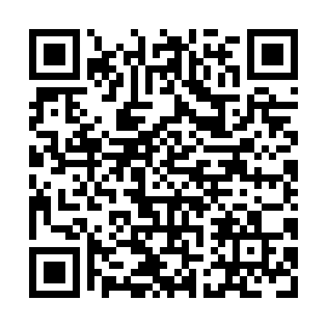
Prayer times for Britannia Creek, Yukon, Canada
Wed 1 May 2024 - Fri 31 May 2024
High Latitude Method: Angle Based Rule
Prayer Calculation Method: Islamic Society of North America
Asar Calculation Method: Hanafi

Date | Day | Fajr | Sunrise | Dhuhr | Asr | Maghrib | Isha
1 | Wed | 4:03 | 5:53 | 2:12 | 7:35 | 10:32 | 12:22
2 | Thu | 4:01 | 5:50 | 2:12 | 7:36 | 10:35 | 12:24
3 | Fri | 4:00 | 5:47 | 2:12 | 7:38 | 10:38 | 12:25
4 | Sat | 3:58 | 5:44 | 2:11 | 7:39 | 10:41 | 12:27
5 | Sun | 3:56 | 5:41 | 2:11 | 7:41 | 10:44 | 12:28
6 | Mon | 3:55 | 5:37 | 2:11 | 7:43 | 10:47 | 12:29
7 | Tue | 3:53 | 5:34 | 2:11 | 7:44 | 10:50 | 12:31
8 | Wed | 3:52 | 5:31 | 2:11 | 7:46 | 10:53 | 12:32
9 | Thu | 3:50 | 5:28 | 2:11 | 7:47 | 10:56 | 12:34
10 | Fri | 3:49 | 5:25 | 2:11 | 7:49 | 10:59 | 12:35
11 | Sat | 3:47 | 5:22 | 2:11 | 7:50 | 11:01 | 12:37
12 | Sun | 3:46 | 5:19 | 2:11 | 7:52 | 11:04 | 12:38
13 | Mon | 3:44 | 5:16 | 2:11 | 7:53 | 11:07 | 12:40
14 | Tue | 3:43 | 5:13 | 2:11 | 7:55 | 11:10 | 12:41
15 | Wed | 3:41 | 5:11 | 2:11 | 7:56 | 11:13 | 12:42
16 | Thu | 3:40 | 5:08 | 2:11 | 7:57 | 11:16 | 12:44
17 | Fri | 3:38 | 5:05 | 2:11 | 7:59 | 11:19 | 12:45
18 | Sat | 3:37 | 5:02 | 2:11 | 8:00 | 11:22 | 12:47
19 | Sun | 3:36 | 4:59 | 2:11 | 8:01 | 11:25 | 12:48
20 | Mon | 3:34 | 4:57 | 2:11 | 8:03 | 11:27 | 12:50
21 | Tue | 3:33 | 4:54 | 2:11 | 8:04 | 11:30 | 12:51
22 | Wed | 3:32 | 4:51 | 2:12 | 8:05 | 11:33 | 12:53
23 | Thu | 3:31 | 4:49 | 2:12 | 8:06 | 11:36 | 12:54
24 | Fri | 3:29 | 4:46 | 2:12 | 8:08 | 11:38 | 12:55
25 | Sat | 3:28 | 4:44 | 2:12 | 8:09 | 11:41 | 12:57
26 | Sun | 3:27 | 4:41 | 2:12 | 8:10 | 11:44 | 12:58
27 | Mon | 3:26 | 4:39 | 2:12 | 8:11 | 11:46 | 12:59
28 | Tue | 3:25 | 4:37 | 2:12 | 8:12 | 11:49 | 1:01
29 | Wed | 3:24 | 4:35 | 2:12 | 8:13 | 11:51 | 1:02
30 | Thu | 3:23 | 4:32 | 2:12 | 8:14 | 11:54 | 1:03
31 | Fri | 3:22 | 4:30 | 2:13 | 8:15 | 11:56 | 1:05
Prayer times provided by https://www.salahtimes.com

