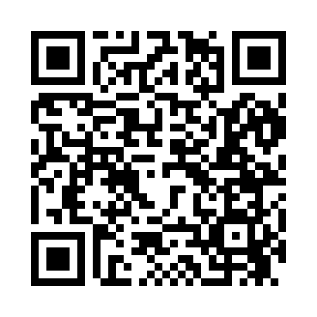
Prayer times for Sugar Beach, Missouri, USA
Mon 1 Jul 2024 - Wed 31 Jul 2024
High Latitude Method: Angle Based Rule
Prayer Calculation Method: Islamic Society of North America
Asar Calculation Method: Shafi

Date | Day | Fajr | Sunrise | Dhuhr | Asr | Maghrib | Isha
1 | Mon | 4:34 | 6:03 | 1:22 | 5:13 | 8:40 | 10:09
2 | Tue | 4:35 | 6:03 | 1:22 | 5:13 | 8:40 | 10:08
3 | Wed | 4:36 | 6:04 | 1:22 | 5:13 | 8:40 | 10:08
4 | Thu | 4:36 | 6:04 | 1:22 | 5:13 | 8:39 | 10:08
5 | Fri | 4:37 | 6:05 | 1:22 | 5:13 | 8:39 | 10:07
6 | Sat | 4:38 | 6:06 | 1:22 | 5:13 | 8:39 | 10:07
7 | Sun | 4:38 | 6:06 | 1:23 | 5:13 | 8:39 | 10:06
8 | Mon | 4:39 | 6:07 | 1:23 | 5:14 | 8:38 | 10:06
9 | Tue | 4:40 | 6:07 | 1:23 | 5:14 | 8:38 | 10:05
10 | Wed | 4:41 | 6:08 | 1:23 | 5:14 | 8:38 | 10:05
11 | Thu | 4:42 | 6:09 | 1:23 | 5:14 | 8:37 | 10:04
12 | Fri | 4:42 | 6:09 | 1:23 | 5:14 | 8:37 | 10:04
13 | Sat | 4:43 | 6:10 | 1:23 | 5:14 | 8:37 | 10:03
14 | Sun | 4:44 | 6:11 | 1:23 | 5:14 | 8:36 | 10:02
15 | Mon | 4:45 | 6:11 | 1:24 | 5:14 | 8:36 | 10:01
16 | Tue | 4:46 | 6:12 | 1:24 | 5:14 | 8:35 | 10:01
17 | Wed | 4:47 | 6:13 | 1:24 | 5:14 | 8:35 | 10:00
18 | Thu | 4:48 | 6:13 | 1:24 | 5:14 | 8:34 | 9:59
19 | Fri | 4:49 | 6:14 | 1:24 | 5:14 | 8:33 | 9:58
20 | Sat | 4:50 | 6:15 | 1:24 | 5:14 | 8:33 | 9:57
21 | Sun | 4:51 | 6:15 | 1:24 | 5:14 | 8:32 | 9:56
22 | Mon | 4:52 | 6:16 | 1:24 | 5:14 | 8:31 | 9:55
23 | Tue | 4:53 | 6:17 | 1:24 | 5:14 | 8:31 | 9:54
24 | Wed | 4:54 | 6:18 | 1:24 | 5:13 | 8:30 | 9:53
25 | Thu | 4:55 | 6:19 | 1:24 | 5:13 | 8:29 | 9:52
26 | Fri | 4:56 | 6:19 | 1:24 | 5:13 | 8:28 | 9:51
27 | Sat | 4:57 | 6:20 | 1:24 | 5:13 | 8:28 | 9:50
28 | Sun | 4:58 | 6:21 | 1:24 | 5:13 | 8:27 | 9:49
29 | Mon | 4:59 | 6:22 | 1:24 | 5:13 | 8:26 | 9:48
30 | Tue | 5:01 | 6:22 | 1:24 | 5:12 | 8:25 | 9:47
31 | Wed | 5:02 | 6:23 | 1:24 | 5:12 | 8:24 | 9:45
Prayer times provided by https://www.salahtimes.com

