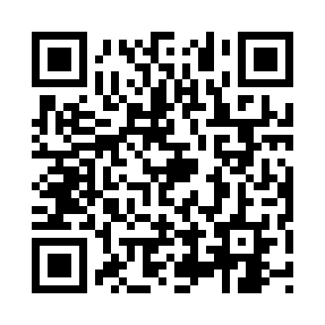
Prayer times for Slobotka, Estonia
Wed 1 May 2024 - Fri 31 May 2024
High Latitude Method: Angle Based Rule
Prayer Calculation Method: Muslim World League
Asar Calculation Method: Hanafi

Date | Day | Fajr | Sunrise | Dhuhr | Asr | Maghrib | Isha
1 | Wed | 2:47 | 5:16 | 1:07 | 6:21 | 8:58 | 11:19
2 | Thu | 2:46 | 5:14 | 1:06 | 6:23 | 9:00 | 11:20
3 | Fri | 2:45 | 5:11 | 1:06 | 6:24 | 9:02 | 11:21
4 | Sat | 2:44 | 5:09 | 1:06 | 6:25 | 9:05 | 11:22
5 | Sun | 2:43 | 5:07 | 1:06 | 6:27 | 9:07 | 11:23
6 | Mon | 2:42 | 5:04 | 1:06 | 6:28 | 9:09 | 11:24
7 | Tue | 2:41 | 5:02 | 1:06 | 6:29 | 9:11 | 11:25
8 | Wed | 2:40 | 5:00 | 1:06 | 6:30 | 9:13 | 11:26
9 | Thu | 2:39 | 4:57 | 1:06 | 6:32 | 9:16 | 11:26
10 | Fri | 2:38 | 4:55 | 1:06 | 6:33 | 9:18 | 11:27
11 | Sat | 2:37 | 4:53 | 1:06 | 6:34 | 9:20 | 11:28
12 | Sun | 2:36 | 4:51 | 1:06 | 6:35 | 9:22 | 11:29
13 | Mon | 2:35 | 4:49 | 1:06 | 6:37 | 9:24 | 11:30
14 | Tue | 2:35 | 4:47 | 1:06 | 6:38 | 9:26 | 11:31
15 | Wed | 2:34 | 4:45 | 1:06 | 6:39 | 9:28 | 11:32
16 | Thu | 2:33 | 4:43 | 1:06 | 6:40 | 9:30 | 11:33
17 | Fri | 2:32 | 4:41 | 1:06 | 6:41 | 9:32 | 11:34
18 | Sat | 2:31 | 4:39 | 1:06 | 6:42 | 9:34 | 11:35
19 | Sun | 2:31 | 4:37 | 1:06 | 6:43 | 9:36 | 11:35
20 | Mon | 2:30 | 4:35 | 1:06 | 6:44 | 9:38 | 11:36
21 | Tue | 2:29 | 4:33 | 1:06 | 6:45 | 9:40 | 11:37
22 | Wed | 2:29 | 4:31 | 1:06 | 6:46 | 9:42 | 11:38
23 | Thu | 2:28 | 4:30 | 1:06 | 6:48 | 9:44 | 11:39
24 | Fri | 2:27 | 4:28 | 1:06 | 6:48 | 9:46 | 11:40
25 | Sat | 2:27 | 4:26 | 1:07 | 6:49 | 9:48 | 11:41
26 | Sun | 2:26 | 4:25 | 1:07 | 6:50 | 9:49 | 11:41
27 | Mon | 2:26 | 4:23 | 1:07 | 6:51 | 9:51 | 11:42
28 | Tue | 2:25 | 4:22 | 1:07 | 6:52 | 9:53 | 11:43
29 | Wed | 2:25 | 4:20 | 1:07 | 6:53 | 9:54 | 11:44
30 | Thu | 2:24 | 4:19 | 1:07 | 6:54 | 9:56 | 11:45
31 | Fri | 2:24 | 4:18 | 1:07 | 6:55 | 9:58 | 11:45
Prayer times provided by https://www.salahtimes.com

