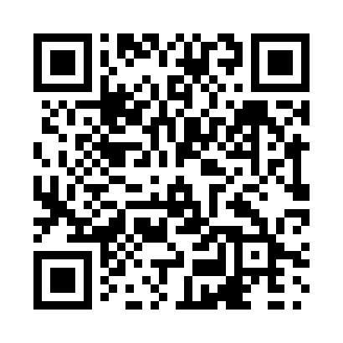
Prayer times for Brunkild, Manitoba, Canada
Wed 1 May 2024 - Fri 31 May 2024
High Latitude Method: Angle Based Rule
Prayer Calculation Method: Islamic Society of North America
Asar Calculation Method: Hanafi

Date | Day | Fajr | Sunrise | Dhuhr | Asr | Maghrib | Isha
1 | Wed | 4:18 | 6:07 | 1:27 | 6:33 | 8:49 | 10:38
2 | Thu | 4:15 | 6:05 | 1:27 | 6:34 | 8:50 | 10:40
3 | Fri | 4:13 | 6:03 | 1:27 | 6:35 | 8:52 | 10:43
4 | Sat | 4:10 | 6:02 | 1:27 | 6:35 | 8:53 | 10:45
5 | Sun | 4:08 | 6:00 | 1:27 | 6:36 | 8:55 | 10:47
6 | Mon | 4:05 | 5:58 | 1:27 | 6:37 | 8:56 | 10:50
7 | Tue | 4:03 | 5:57 | 1:27 | 6:38 | 8:58 | 10:52
8 | Wed | 4:00 | 5:55 | 1:27 | 6:39 | 8:59 | 10:55
9 | Thu | 3:58 | 5:54 | 1:27 | 6:40 | 9:01 | 10:57
10 | Fri | 3:55 | 5:52 | 1:27 | 6:41 | 9:02 | 10:59
11 | Sat | 3:53 | 5:51 | 1:27 | 6:42 | 9:04 | 11:02
12 | Sun | 3:50 | 5:49 | 1:27 | 6:42 | 9:05 | 11:04
13 | Mon | 3:48 | 5:48 | 1:27 | 6:43 | 9:06 | 11:07
14 | Tue | 3:46 | 5:46 | 1:27 | 6:44 | 9:08 | 11:09
15 | Wed | 3:43 | 5:45 | 1:27 | 6:45 | 9:09 | 11:12
16 | Thu | 3:41 | 5:44 | 1:27 | 6:46 | 9:10 | 11:14
17 | Fri | 3:38 | 5:42 | 1:27 | 6:47 | 9:12 | 11:16
18 | Sat | 3:36 | 5:41 | 1:27 | 6:47 | 9:13 | 11:19
19 | Sun | 3:34 | 5:40 | 1:27 | 6:48 | 9:14 | 11:21
20 | Mon | 3:33 | 5:39 | 1:27 | 6:49 | 9:16 | 11:21
21 | Tue | 3:32 | 5:38 | 1:27 | 6:50 | 9:17 | 11:22
22 | Wed | 3:32 | 5:36 | 1:27 | 6:50 | 9:18 | 11:23
23 | Thu | 3:31 | 5:35 | 1:27 | 6:51 | 9:19 | 11:23
24 | Fri | 3:31 | 5:34 | 1:27 | 6:52 | 9:21 | 11:24
25 | Sat | 3:30 | 5:33 | 1:27 | 6:53 | 9:22 | 11:25
26 | Sun | 3:30 | 5:32 | 1:27 | 6:53 | 9:23 | 11:25
27 | Mon | 3:30 | 5:31 | 1:28 | 6:54 | 9:24 | 11:26
28 | Tue | 3:29 | 5:31 | 1:28 | 6:55 | 9:25 | 11:27
29 | Wed | 3:29 | 5:30 | 1:28 | 6:55 | 9:26 | 11:27
30 | Thu | 3:29 | 5:29 | 1:28 | 6:56 | 9:27 | 11:28
31 | Fri | 3:28 | 5:28 | 1:28 | 6:56 | 9:28 | 11:28
Prayer times provided by https://www.salahtimes.com

