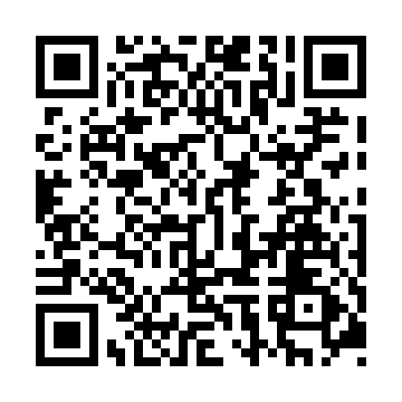
Prayer times for Quebec Harbour, Ontario, Canada
Mon 1 Jul 2024 - Wed 31 Jul 2024
High Latitude Method: Angle Based Rule
Prayer Calculation Method: Islamic Society of North America
Asar Calculation Method: Hanafi

Date | Day | Fajr | Sunrise | Dhuhr | Asr | Maghrib | Isha
1 | Mon | 3:48 | 5:49 | 1:47 | 7:15 | 9:45 | 11:46
2 | Tue | 3:49 | 5:50 | 1:47 | 7:15 | 9:44 | 11:46
3 | Wed | 3:49 | 5:51 | 1:48 | 7:15 | 9:44 | 11:46
4 | Thu | 3:49 | 5:51 | 1:48 | 7:15 | 9:44 | 11:46
5 | Fri | 3:50 | 5:52 | 1:48 | 7:14 | 9:43 | 11:46
6 | Sat | 3:50 | 5:53 | 1:48 | 7:14 | 9:43 | 11:45
7 | Sun | 3:51 | 5:54 | 1:48 | 7:14 | 9:42 | 11:45
8 | Mon | 3:51 | 5:55 | 1:48 | 7:14 | 9:42 | 11:45
9 | Tue | 3:52 | 5:55 | 1:48 | 7:14 | 9:41 | 11:45
10 | Wed | 3:52 | 5:56 | 1:49 | 7:13 | 9:41 | 11:44
11 | Thu | 3:53 | 5:57 | 1:49 | 7:13 | 9:40 | 11:44
12 | Fri | 3:53 | 5:58 | 1:49 | 7:13 | 9:39 | 11:43
13 | Sat | 3:55 | 5:59 | 1:49 | 7:12 | 9:38 | 11:42
14 | Sun | 3:57 | 6:00 | 1:49 | 7:12 | 9:38 | 11:40
15 | Mon | 3:59 | 6:01 | 1:49 | 7:12 | 9:37 | 11:39
16 | Tue | 4:01 | 6:02 | 1:49 | 7:11 | 9:36 | 11:37
17 | Wed | 4:03 | 6:03 | 1:49 | 7:11 | 9:35 | 11:35
18 | Thu | 4:04 | 6:04 | 1:49 | 7:10 | 9:34 | 11:33
19 | Fri | 4:06 | 6:05 | 1:50 | 7:10 | 9:33 | 11:32
20 | Sat | 4:08 | 6:07 | 1:50 | 7:09 | 9:32 | 11:30
21 | Sun | 4:10 | 6:08 | 1:50 | 7:08 | 9:31 | 11:28
22 | Mon | 4:12 | 6:09 | 1:50 | 7:08 | 9:30 | 11:26
23 | Tue | 4:14 | 6:10 | 1:50 | 7:07 | 9:29 | 11:24
24 | Wed | 4:16 | 6:11 | 1:50 | 7:07 | 9:28 | 11:22
25 | Thu | 4:18 | 6:12 | 1:50 | 7:06 | 9:26 | 11:20
26 | Fri | 4:20 | 6:14 | 1:50 | 7:05 | 9:25 | 11:18
27 | Sat | 4:22 | 6:15 | 1:50 | 7:04 | 9:24 | 11:16
28 | Sun | 4:24 | 6:16 | 1:50 | 7:04 | 9:23 | 11:14
29 | Mon | 4:26 | 6:17 | 1:50 | 7:03 | 9:21 | 11:12
30 | Tue | 4:28 | 6:19 | 1:50 | 7:02 | 9:20 | 11:10
31 | Wed | 4:30 | 6:20 | 1:49 | 7:01 | 9:19 | 11:07
Prayer times provided by https://www.salahtimes.com

