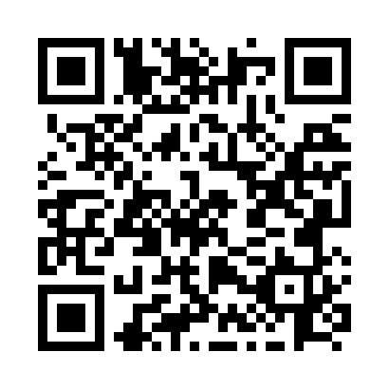
Prayer times for Cains Island, Newfoundland and Labrador, Canada
Mon 1 Jul 2024 - Wed 31 Jul 2024
High Latitude Method: Angle Based Rule
Prayer Calculation Method: Islamic Society of North America
Asar Calculation Method: Hanafi

Date | Day | Fajr | Sunrise | Dhuhr | Asr | Maghrib | Isha
1 | Mon | 3:30 | 5:32 | 1:29 | 6:56 | 9:26 | 11:27
2 | Tue | 3:31 | 5:32 | 1:29 | 6:56 | 9:26 | 11:27
3 | Wed | 3:31 | 5:33 | 1:29 | 6:56 | 9:25 | 11:27
4 | Thu | 3:31 | 5:34 | 1:29 | 6:56 | 9:25 | 11:27
5 | Fri | 3:32 | 5:34 | 1:30 | 6:56 | 9:25 | 11:27
6 | Sat | 3:32 | 5:35 | 1:30 | 6:56 | 9:24 | 11:27
7 | Sun | 3:33 | 5:36 | 1:30 | 6:55 | 9:24 | 11:27
8 | Mon | 3:33 | 5:37 | 1:30 | 6:55 | 9:23 | 11:26
9 | Tue | 3:34 | 5:38 | 1:30 | 6:55 | 9:22 | 11:26
10 | Wed | 3:34 | 5:38 | 1:30 | 6:55 | 9:22 | 11:26
11 | Thu | 3:35 | 5:39 | 1:30 | 6:54 | 9:21 | 11:25
12 | Fri | 3:36 | 5:40 | 1:31 | 6:54 | 9:20 | 11:24
13 | Sat | 3:38 | 5:41 | 1:31 | 6:54 | 9:20 | 11:22
14 | Sun | 3:40 | 5:42 | 1:31 | 6:53 | 9:19 | 11:21
15 | Mon | 3:42 | 5:43 | 1:31 | 6:53 | 9:18 | 11:19
16 | Tue | 3:43 | 5:44 | 1:31 | 6:53 | 9:17 | 11:18
17 | Wed | 3:45 | 5:45 | 1:31 | 6:52 | 9:16 | 11:16
18 | Thu | 3:47 | 5:46 | 1:31 | 6:52 | 9:15 | 11:14
19 | Fri | 3:49 | 5:47 | 1:31 | 6:51 | 9:14 | 11:12
20 | Sat | 3:51 | 5:49 | 1:31 | 6:51 | 9:13 | 11:11
21 | Sun | 3:53 | 5:50 | 1:31 | 6:50 | 9:12 | 11:09
22 | Mon | 3:55 | 5:51 | 1:31 | 6:49 | 9:11 | 11:07
23 | Tue | 3:57 | 5:52 | 1:31 | 6:49 | 9:10 | 11:05
24 | Wed | 3:59 | 5:53 | 1:31 | 6:48 | 9:09 | 11:03
25 | Thu | 4:01 | 5:54 | 1:31 | 6:47 | 9:08 | 11:01
26 | Fri | 4:03 | 5:56 | 1:31 | 6:47 | 9:07 | 10:59
27 | Sat | 4:05 | 5:57 | 1:31 | 6:46 | 9:05 | 10:57
28 | Sun | 4:07 | 5:58 | 1:31 | 6:45 | 9:04 | 10:55
29 | Mon | 4:09 | 5:59 | 1:31 | 6:44 | 9:03 | 10:53
30 | Tue | 4:11 | 6:01 | 1:31 | 6:44 | 9:01 | 10:51
31 | Wed | 4:13 | 6:02 | 1:31 | 6:43 | 9:00 | 10:49
Prayer times provided by https://www.salahtimes.com

