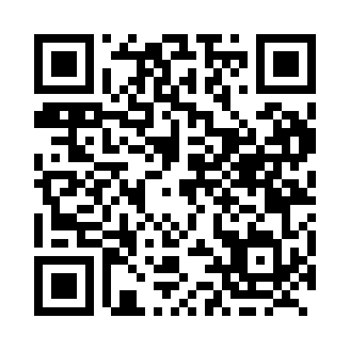
Prayer times for Beckwith, Nova Scotia, Canada
Wed 1 May 2024 - Fri 31 May 2024
High Latitude Method: Angle Based Rule
Prayer Calculation Method: Islamic Society of North America
Asar Calculation Method: Hanafi

Date | Day | Fajr | Sunrise | Dhuhr | Asr | Maghrib | Isha
1 | Wed | 4:25 | 6:02 | 1:12 | 6:14 | 8:24 | 10:00
2 | Thu | 4:23 | 6:00 | 1:12 | 6:14 | 8:25 | 10:02
3 | Fri | 4:21 | 5:59 | 1:12 | 6:15 | 8:26 | 10:04
4 | Sat | 4:19 | 5:57 | 1:12 | 6:16 | 8:27 | 10:06
5 | Sun | 4:17 | 5:56 | 1:12 | 6:17 | 8:29 | 10:08
6 | Mon | 4:15 | 5:54 | 1:12 | 6:17 | 8:30 | 10:10
7 | Tue | 4:13 | 5:53 | 1:12 | 6:18 | 8:31 | 10:12
8 | Wed | 4:11 | 5:52 | 1:12 | 6:19 | 8:32 | 10:13
9 | Thu | 4:09 | 5:50 | 1:12 | 6:20 | 8:34 | 10:15
10 | Fri | 4:07 | 5:49 | 1:12 | 6:20 | 8:35 | 10:17
11 | Sat | 4:05 | 5:48 | 1:12 | 6:21 | 8:36 | 10:19
12 | Sun | 4:03 | 5:47 | 1:12 | 6:22 | 8:37 | 10:21
13 | Mon | 4:02 | 5:45 | 1:12 | 6:22 | 8:38 | 10:23
14 | Tue | 4:00 | 5:44 | 1:12 | 6:23 | 8:40 | 10:24
15 | Wed | 3:58 | 5:43 | 1:12 | 6:24 | 8:41 | 10:26
16 | Thu | 3:56 | 5:42 | 1:12 | 6:25 | 8:42 | 10:28
17 | Fri | 3:54 | 5:41 | 1:12 | 6:25 | 8:43 | 10:30
18 | Sat | 3:53 | 5:40 | 1:12 | 6:26 | 8:44 | 10:32
19 | Sun | 3:51 | 5:39 | 1:12 | 6:27 | 8:45 | 10:33
20 | Mon | 3:49 | 5:38 | 1:12 | 6:27 | 8:47 | 10:35
21 | Tue | 3:48 | 5:37 | 1:12 | 6:28 | 8:48 | 10:37
22 | Wed | 3:46 | 5:36 | 1:12 | 6:29 | 8:49 | 10:39
23 | Thu | 3:45 | 5:35 | 1:12 | 6:29 | 8:50 | 10:40
24 | Fri | 3:43 | 5:34 | 1:12 | 6:30 | 8:51 | 10:42
25 | Sat | 3:42 | 5:33 | 1:12 | 6:30 | 8:52 | 10:44
26 | Sun | 3:40 | 5:32 | 1:12 | 6:31 | 8:53 | 10:45
27 | Mon | 3:39 | 5:32 | 1:13 | 6:32 | 8:54 | 10:47
28 | Tue | 3:38 | 5:31 | 1:13 | 6:32 | 8:55 | 10:48
29 | Wed | 3:36 | 5:30 | 1:13 | 6:33 | 8:56 | 10:50
30 | Thu | 3:35 | 5:30 | 1:13 | 6:33 | 8:57 | 10:51
31 | Fri | 3:34 | 5:29 | 1:13 | 6:34 | 8:58 | 10:53
Prayer times provided by https://www.salahtimes.com

