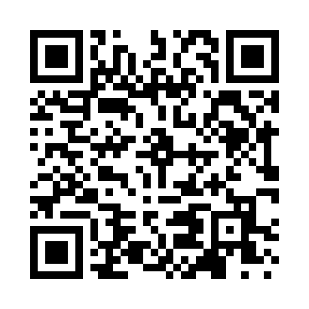
Prayer times for Bucks Harbor, Maine, USA
Mon 1 Jul 2024 - Wed 31 Jul 2024
High Latitude Method: Angle Based Rule
Prayer Calculation Method: Islamic Society of North America
Asar Calculation Method: Shafi

Date | Day | Fajr | Sunrise | Dhuhr | Asr | Maghrib | Isha
1 | Mon | 2:55 | 4:48 | 12:34 | 4:42 | 8:18 | 10:12
2 | Tue | 2:56 | 4:49 | 12:34 | 4:42 | 8:18 | 10:11
3 | Wed | 2:57 | 4:50 | 12:34 | 4:42 | 8:18 | 10:11
4 | Thu | 2:58 | 4:50 | 12:34 | 4:42 | 8:18 | 10:10
5 | Fri | 2:59 | 4:51 | 12:34 | 4:42 | 8:17 | 10:09
6 | Sat | 3:00 | 4:52 | 12:34 | 4:42 | 8:17 | 10:09
7 | Sun | 3:01 | 4:52 | 12:35 | 4:42 | 8:17 | 10:08
8 | Mon | 3:02 | 4:53 | 12:35 | 4:42 | 8:16 | 10:07
9 | Tue | 3:03 | 4:54 | 12:35 | 4:42 | 8:16 | 10:06
10 | Wed | 3:05 | 4:55 | 12:35 | 4:42 | 8:15 | 10:05
11 | Thu | 3:06 | 4:56 | 12:35 | 4:42 | 8:14 | 10:04
12 | Fri | 3:07 | 4:56 | 12:35 | 4:42 | 8:14 | 10:03
13 | Sat | 3:09 | 4:57 | 12:35 | 4:42 | 8:13 | 10:02
14 | Sun | 3:10 | 4:58 | 12:36 | 4:41 | 8:13 | 10:00
15 | Mon | 3:11 | 4:59 | 12:36 | 4:41 | 8:12 | 9:59
16 | Tue | 3:13 | 5:00 | 12:36 | 4:41 | 8:11 | 9:58
17 | Wed | 3:14 | 5:01 | 12:36 | 4:41 | 8:10 | 9:57
18 | Thu | 3:16 | 5:02 | 12:36 | 4:41 | 8:09 | 9:55
19 | Fri | 3:17 | 5:03 | 12:36 | 4:41 | 8:09 | 9:54
20 | Sat | 3:19 | 5:04 | 12:36 | 4:40 | 8:08 | 9:52
21 | Sun | 3:20 | 5:05 | 12:36 | 4:40 | 8:07 | 9:51
22 | Mon | 3:22 | 5:06 | 12:36 | 4:40 | 8:06 | 9:49
23 | Tue | 3:23 | 5:07 | 12:36 | 4:40 | 8:05 | 9:48
24 | Wed | 3:25 | 5:08 | 12:36 | 4:39 | 8:04 | 9:46
25 | Thu | 3:27 | 5:09 | 12:36 | 4:39 | 8:03 | 9:45
26 | Fri | 3:28 | 5:10 | 12:36 | 4:38 | 8:02 | 9:43
27 | Sat | 3:30 | 5:11 | 12:36 | 4:38 | 8:01 | 9:41
28 | Sun | 3:32 | 5:12 | 12:36 | 4:38 | 7:59 | 9:40
29 | Mon | 3:33 | 5:13 | 12:36 | 4:37 | 7:58 | 9:38
30 | Tue | 3:35 | 5:14 | 12:36 | 4:37 | 7:57 | 9:36
31 | Wed | 3:37 | 5:15 | 12:36 | 4:36 | 7:56 | 9:34
Prayer times provided by https://www.salahtimes.com

