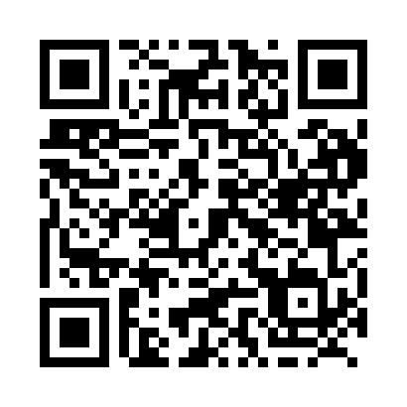
Prayer times for Brig Bay, Newfoundland and Labrador, Canada
Wed 1 May 2024 - Fri 31 May 2024
High Latitude Method: Angle Based Rule
Prayer Calculation Method: Islamic Society of North America
Asar Calculation Method: Hanafi

Date | Day | Fajr | Sunrise | Dhuhr | Asr | Maghrib | Isha
1 | Wed | 3:55 | 5:50 | 1:15 | 6:22 | 8:40 | 10:36
2 | Thu | 3:52 | 5:48 | 1:15 | 6:23 | 8:42 | 10:38
3 | Fri | 3:50 | 5:46 | 1:14 | 6:24 | 8:44 | 10:41
4 | Sat | 3:47 | 5:44 | 1:14 | 6:25 | 8:45 | 10:44
5 | Sun | 3:44 | 5:43 | 1:14 | 6:25 | 8:47 | 10:46
6 | Mon | 3:41 | 5:41 | 1:14 | 6:26 | 8:48 | 10:49
7 | Tue | 3:38 | 5:39 | 1:14 | 6:27 | 8:50 | 10:52
8 | Wed | 3:35 | 5:38 | 1:14 | 6:28 | 8:51 | 10:54
9 | Thu | 3:33 | 5:36 | 1:14 | 6:29 | 8:53 | 10:57
10 | Fri | 3:30 | 5:34 | 1:14 | 6:30 | 8:55 | 11:00
11 | Sat | 3:27 | 5:33 | 1:14 | 6:31 | 8:56 | 11:03
12 | Sun | 3:24 | 5:31 | 1:14 | 6:32 | 8:58 | 11:05
13 | Mon | 3:22 | 5:30 | 1:14 | 6:33 | 8:59 | 11:07
14 | Tue | 3:21 | 5:28 | 1:14 | 6:34 | 9:01 | 11:07
15 | Wed | 3:21 | 5:27 | 1:14 | 6:35 | 9:02 | 11:08
16 | Thu | 3:20 | 5:25 | 1:14 | 6:35 | 9:04 | 11:09
17 | Fri | 3:19 | 5:24 | 1:14 | 6:36 | 9:05 | 11:10
18 | Sat | 3:19 | 5:23 | 1:14 | 6:37 | 9:06 | 11:10
19 | Sun | 3:18 | 5:21 | 1:14 | 6:38 | 9:08 | 11:11
20 | Mon | 3:17 | 5:20 | 1:14 | 6:39 | 9:09 | 11:12
21 | Tue | 3:17 | 5:19 | 1:14 | 6:40 | 9:10 | 11:13
22 | Wed | 3:16 | 5:18 | 1:14 | 6:40 | 9:12 | 11:13
23 | Thu | 3:16 | 5:16 | 1:14 | 6:41 | 9:13 | 11:14
24 | Fri | 3:15 | 5:15 | 1:15 | 6:42 | 9:14 | 11:15
25 | Sat | 3:15 | 5:14 | 1:15 | 6:43 | 9:16 | 11:15
26 | Sun | 3:14 | 5:13 | 1:15 | 6:43 | 9:17 | 11:16
27 | Mon | 3:14 | 5:12 | 1:15 | 6:44 | 9:18 | 11:17
28 | Tue | 3:13 | 5:11 | 1:15 | 6:45 | 9:19 | 11:17
29 | Wed | 3:13 | 5:10 | 1:15 | 6:46 | 9:20 | 11:18
30 | Thu | 3:13 | 5:10 | 1:15 | 6:46 | 9:22 | 11:19
31 | Fri | 3:12 | 5:09 | 1:15 | 6:47 | 9:23 | 11:19
Prayer times provided by https://www.salahtimes.com

