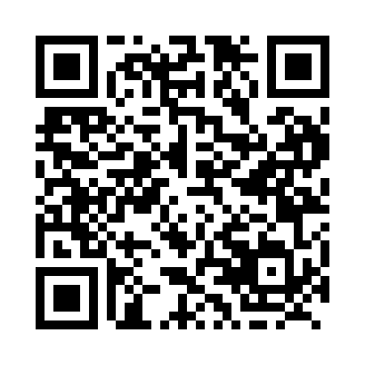
Prayer times for Inukjuak, Quebec, Canada
Mon 1 Jul 2024 - Wed 31 Jul 2024
High Latitude Method: Angle Based Rule
Prayer Calculation Method: Islamic Society of North America
Asar Calculation Method: Hanafi

Date | Day | Fajr | Sunrise | Dhuhr | Asr | Maghrib | Isha
1 | Mon | 2:44 | 4:11 | 1:16 | 7:10 | 10:21 | 11:49
2 | Tue | 2:44 | 4:12 | 1:17 | 7:10 | 10:21 | 11:49
3 | Wed | 2:45 | 4:13 | 1:17 | 7:10 | 10:20 | 11:48
4 | Thu | 2:46 | 4:14 | 1:17 | 7:10 | 10:19 | 11:48
5 | Fri | 2:46 | 4:16 | 1:17 | 7:09 | 10:18 | 11:48
6 | Sat | 2:47 | 4:17 | 1:17 | 7:09 | 10:17 | 11:47
7 | Sun | 2:48 | 4:18 | 1:17 | 7:09 | 10:16 | 11:47
8 | Mon | 2:48 | 4:20 | 1:18 | 7:08 | 10:15 | 11:46
9 | Tue | 2:49 | 4:21 | 1:18 | 7:08 | 10:14 | 11:46
10 | Wed | 2:50 | 4:23 | 1:18 | 7:07 | 10:13 | 11:45
11 | Thu | 2:51 | 4:24 | 1:18 | 7:07 | 10:11 | 11:44
12 | Fri | 2:52 | 4:26 | 1:18 | 7:06 | 10:10 | 11:44
13 | Sat | 2:53 | 4:27 | 1:18 | 7:05 | 10:08 | 11:43
14 | Sun | 2:54 | 4:29 | 1:18 | 7:05 | 10:07 | 11:42
15 | Mon | 2:54 | 4:31 | 1:18 | 7:04 | 10:05 | 11:42
16 | Tue | 2:55 | 4:33 | 1:19 | 7:03 | 10:04 | 11:41
17 | Wed | 2:56 | 4:34 | 1:19 | 7:02 | 10:02 | 11:40
18 | Thu | 2:57 | 4:36 | 1:19 | 7:02 | 10:00 | 11:39
19 | Fri | 2:58 | 4:38 | 1:19 | 7:01 | 9:59 | 11:38
20 | Sat | 2:59 | 4:40 | 1:19 | 7:00 | 9:57 | 11:38
21 | Sun | 3:00 | 4:42 | 1:19 | 6:59 | 9:55 | 11:37
22 | Mon | 3:01 | 4:44 | 1:19 | 6:58 | 9:53 | 11:36
23 | Tue | 3:02 | 4:46 | 1:19 | 6:57 | 9:51 | 11:35
24 | Wed | 3:03 | 4:48 | 1:19 | 6:56 | 9:49 | 11:34
25 | Thu | 3:04 | 4:50 | 1:19 | 6:55 | 9:47 | 11:33
26 | Fri | 3:05 | 4:52 | 1:19 | 6:54 | 9:45 | 11:32
27 | Sat | 3:06 | 4:54 | 1:19 | 6:53 | 9:43 | 11:31
28 | Sun | 3:07 | 4:56 | 1:19 | 6:51 | 9:41 | 11:30
29 | Mon | 3:08 | 4:58 | 1:19 | 6:50 | 9:39 | 11:28
30 | Tue | 3:09 | 5:00 | 1:19 | 6:49 | 9:36 | 11:27
31 | Wed | 3:10 | 5:02 | 1:19 | 6:48 | 9:34 | 11:26
Prayer times provided by https://www.salahtimes.com

