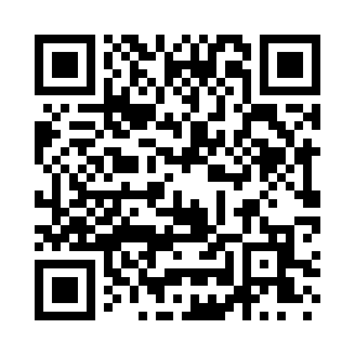
Prayer times for Arrow Point, Missouri, USA
Wed 1 May 2024 - Fri 31 May 2024
High Latitude Method: Angle Based Rule
Prayer Calculation Method: Islamic Society of North America
Asar Calculation Method: Shafi

Date | Day | Fajr | Sunrise | Dhuhr | Asr | Maghrib | Isha
1 | Wed | 5:02 | 6:20 | 1:12 | 4:58 | 8:03 | 9:22
2 | Thu | 5:00 | 6:19 | 1:11 | 4:58 | 8:04 | 9:23
3 | Fri | 4:59 | 6:18 | 1:11 | 4:58 | 8:05 | 9:24
4 | Sat | 4:58 | 6:17 | 1:11 | 4:58 | 8:06 | 9:25
5 | Sun | 4:56 | 6:16 | 1:11 | 4:58 | 8:07 | 9:27
6 | Mon | 4:55 | 6:15 | 1:11 | 4:58 | 8:08 | 9:28
7 | Tue | 4:54 | 6:14 | 1:11 | 4:59 | 8:08 | 9:29
8 | Wed | 4:52 | 6:13 | 1:11 | 4:59 | 8:09 | 9:30
9 | Thu | 4:51 | 6:12 | 1:11 | 4:59 | 8:10 | 9:31
10 | Fri | 4:50 | 6:11 | 1:11 | 4:59 | 8:11 | 9:32
11 | Sat | 4:49 | 6:10 | 1:11 | 4:59 | 8:12 | 9:33
12 | Sun | 4:48 | 6:09 | 1:11 | 4:59 | 8:13 | 9:35
13 | Mon | 4:47 | 6:09 | 1:11 | 5:00 | 8:13 | 9:36
14 | Tue | 4:45 | 6:08 | 1:11 | 5:00 | 8:14 | 9:37
15 | Wed | 4:44 | 6:07 | 1:11 | 5:00 | 8:15 | 9:38
16 | Thu | 4:43 | 6:06 | 1:11 | 5:00 | 8:16 | 9:39
17 | Fri | 4:42 | 6:05 | 1:11 | 5:00 | 8:17 | 9:40
18 | Sat | 4:41 | 6:05 | 1:11 | 5:00 | 8:18 | 9:41
19 | Sun | 4:40 | 6:04 | 1:11 | 5:01 | 8:18 | 9:42
20 | Mon | 4:39 | 6:03 | 1:11 | 5:01 | 8:19 | 9:43
21 | Tue | 4:38 | 6:03 | 1:11 | 5:01 | 8:20 | 9:44
22 | Wed | 4:37 | 6:02 | 1:11 | 5:01 | 8:21 | 9:45
23 | Thu | 4:37 | 6:02 | 1:11 | 5:01 | 8:21 | 9:47
24 | Fri | 4:36 | 6:01 | 1:11 | 5:01 | 8:22 | 9:48
25 | Sat | 4:35 | 6:00 | 1:12 | 5:02 | 8:23 | 9:49
26 | Sun | 4:34 | 6:00 | 1:12 | 5:02 | 8:24 | 9:49
27 | Mon | 4:33 | 5:59 | 1:12 | 5:02 | 8:24 | 9:50
28 | Tue | 4:33 | 5:59 | 1:12 | 5:02 | 8:25 | 9:51
29 | Wed | 4:32 | 5:59 | 1:12 | 5:02 | 8:26 | 9:52
30 | Thu | 4:32 | 5:58 | 1:12 | 5:03 | 8:26 | 9:53
31 | Fri | 4:31 | 5:58 | 1:12 | 5:03 | 8:27 | 9:54
Prayer times provided by https://www.salahtimes.com

