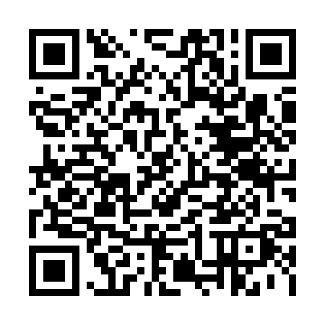
Prayer times for Albergo della Posta, Italy
Wed 1 May 2024 - Fri 31 May 2024
High Latitude Method: Angle Based Rule
Prayer Calculation Method: Muslim World League
Asar Calculation Method: Hanafi

Date | Day | Fajr | Sunrise | Dhuhr | Asr | Maghrib | Isha
1 | Wed | 4:00 | 6:03 | 1:15 | 6:17 | 8:27 | 10:23
2 | Thu | 3:57 | 6:01 | 1:15 | 6:17 | 8:29 | 10:25
3 | Fri | 3:55 | 6:00 | 1:15 | 6:18 | 8:30 | 10:27
4 | Sat | 3:52 | 5:58 | 1:14 | 6:19 | 8:31 | 10:29
5 | Sun | 3:50 | 5:57 | 1:14 | 6:20 | 8:33 | 10:31
6 | Mon | 3:48 | 5:55 | 1:14 | 6:21 | 8:34 | 10:33
7 | Tue | 3:45 | 5:54 | 1:14 | 6:21 | 8:35 | 10:35
8 | Wed | 3:43 | 5:52 | 1:14 | 6:22 | 8:37 | 10:37
9 | Thu | 3:40 | 5:51 | 1:14 | 6:23 | 8:38 | 10:40
10 | Fri | 3:38 | 5:50 | 1:14 | 6:24 | 8:39 | 10:42
11 | Sat | 3:36 | 5:48 | 1:14 | 6:24 | 8:40 | 10:44
12 | Sun | 3:33 | 5:47 | 1:14 | 6:25 | 8:42 | 10:46
13 | Mon | 3:31 | 5:46 | 1:14 | 6:26 | 8:43 | 10:48
14 | Tue | 3:29 | 5:45 | 1:14 | 6:27 | 8:44 | 10:50
15 | Wed | 3:26 | 5:43 | 1:14 | 6:27 | 8:45 | 10:52
16 | Thu | 3:24 | 5:42 | 1:14 | 6:28 | 8:46 | 10:55
17 | Fri | 3:22 | 5:41 | 1:14 | 6:29 | 8:48 | 10:57
18 | Sat | 3:20 | 5:40 | 1:14 | 6:29 | 8:49 | 10:59
19 | Sun | 3:17 | 5:39 | 1:14 | 6:30 | 8:50 | 11:01
20 | Mon | 3:15 | 5:38 | 1:14 | 6:31 | 8:51 | 11:03
21 | Tue | 3:13 | 5:37 | 1:14 | 6:31 | 8:52 | 11:05
22 | Wed | 3:11 | 5:36 | 1:14 | 6:32 | 8:53 | 11:07
23 | Thu | 3:09 | 5:35 | 1:14 | 6:33 | 8:55 | 11:09
24 | Fri | 3:07 | 5:34 | 1:15 | 6:33 | 8:56 | 11:11
25 | Sat | 3:05 | 5:33 | 1:15 | 6:34 | 8:57 | 11:13
26 | Sun | 3:03 | 5:32 | 1:15 | 6:35 | 8:58 | 11:15
27 | Mon | 3:01 | 5:32 | 1:15 | 6:35 | 8:59 | 11:17
28 | Tue | 2:59 | 5:31 | 1:15 | 6:36 | 9:00 | 11:19
29 | Wed | 2:57 | 5:30 | 1:15 | 6:36 | 9:01 | 11:21
30 | Thu | 2:57 | 5:29 | 1:15 | 6:37 | 9:02 | 11:23
31 | Fri | 2:57 | 5:29 | 1:15 | 6:38 | 9:03 | 11:25
Prayer times provided by https://www.salahtimes.com

