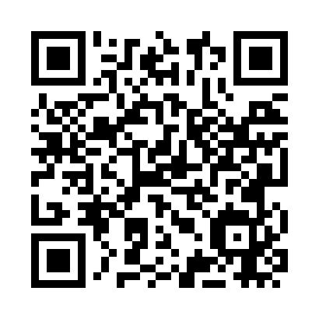
Prayer times for Havana, Cuba
Wed 1 May 2024 - Fri 31 May 2024
High Latitude Method: None
Prayer Calculation Method: Muslim World League
Asar Calculation Method: Shafi

Date | Day | Fajr | Sunrise | Dhuhr | Asr | Maghrib | Isha
1 | Wed | 5:36 | 6:56 | 1:27 | 4:51 | 7:57 | 9:13
2 | Thu | 5:35 | 6:55 | 1:26 | 4:51 | 7:58 | 9:14
3 | Fri | 5:34 | 6:55 | 1:26 | 4:50 | 7:58 | 9:14
4 | Sat | 5:33 | 6:54 | 1:26 | 4:50 | 7:59 | 9:15
5 | Sun | 5:32 | 6:53 | 1:26 | 4:50 | 7:59 | 9:16
6 | Mon | 5:32 | 6:53 | 1:26 | 4:50 | 8:00 | 9:16
7 | Tue | 5:31 | 6:52 | 1:26 | 4:49 | 8:00 | 9:17
8 | Wed | 5:30 | 6:52 | 1:26 | 4:49 | 8:01 | 9:17
9 | Thu | 5:29 | 6:51 | 1:26 | 4:49 | 8:01 | 9:18
10 | Fri | 5:29 | 6:51 | 1:26 | 4:49 | 8:02 | 9:19
11 | Sat | 5:28 | 6:50 | 1:26 | 4:48 | 8:02 | 9:19
12 | Sun | 5:27 | 6:50 | 1:26 | 4:48 | 8:03 | 9:20
13 | Mon | 5:26 | 6:49 | 1:26 | 4:48 | 8:03 | 9:21
14 | Tue | 5:26 | 6:49 | 1:26 | 4:48 | 8:03 | 9:21
15 | Wed | 5:25 | 6:48 | 1:26 | 4:47 | 8:04 | 9:22
16 | Thu | 5:25 | 6:48 | 1:26 | 4:47 | 8:04 | 9:23
17 | Fri | 5:24 | 6:47 | 1:26 | 4:47 | 8:05 | 9:23
18 | Sat | 5:23 | 6:47 | 1:26 | 4:47 | 8:05 | 9:24
19 | Sun | 5:23 | 6:47 | 1:26 | 4:47 | 8:06 | 9:25
20 | Mon | 5:22 | 6:46 | 1:26 | 4:47 | 8:06 | 9:25
21 | Tue | 5:22 | 6:46 | 1:26 | 4:46 | 8:07 | 9:26
22 | Wed | 5:21 | 6:46 | 1:26 | 4:46 | 8:07 | 9:26
23 | Thu | 5:21 | 6:45 | 1:26 | 4:46 | 8:08 | 9:27
24 | Fri | 5:20 | 6:45 | 1:26 | 4:46 | 8:08 | 9:28
25 | Sat | 5:20 | 6:45 | 1:27 | 4:46 | 8:09 | 9:28
26 | Sun | 5:20 | 6:44 | 1:27 | 4:46 | 8:09 | 9:29
27 | Mon | 5:19 | 6:44 | 1:27 | 4:46 | 8:10 | 9:29
28 | Tue | 5:19 | 6:44 | 1:27 | 4:46 | 8:10 | 9:30
29 | Wed | 5:18 | 6:44 | 1:27 | 4:46 | 8:10 | 9:31
30 | Thu | 5:18 | 6:44 | 1:27 | 4:46 | 8:11 | 9:31
31 | Fri | 5:18 | 6:44 | 1:27 | 4:46 | 8:11 | 9:32
Prayer times provided by https://www.salahtimes.com

