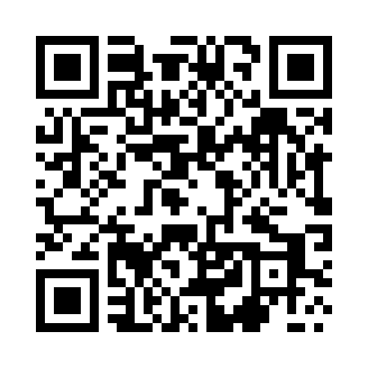
Prayer times for Glomsk, Poland
Mon 1 Apr 2024 - Tue 30 Apr 2024
High Latitude Method: Angle Based Rule
Prayer Calculation Method: Muslim World League
Asar Calculation Method: Hanafi

Date | Day | Fajr | Sunrise | Dhuhr | Asr | Maghrib | Isha
1 | Mon | 4:18 | 6:24 | 12:55 | 5:21 | 7:27 | 9:25
2 | Tue | 4:15 | 6:21 | 12:55 | 5:23 | 7:29 | 9:27
3 | Wed | 4:12 | 6:19 | 12:54 | 5:24 | 7:31 | 9:30
4 | Thu | 4:09 | 6:17 | 12:54 | 5:25 | 7:33 | 9:32
5 | Fri | 4:06 | 6:14 | 12:54 | 5:27 | 7:35 | 9:35
6 | Sat | 4:03 | 6:12 | 12:54 | 5:28 | 7:36 | 9:37
7 | Sun | 4:00 | 6:10 | 12:53 | 5:29 | 7:38 | 9:40
8 | Mon | 3:56 | 6:07 | 12:53 | 5:30 | 7:40 | 9:43
9 | Tue | 3:53 | 6:05 | 12:53 | 5:32 | 7:42 | 9:45
10 | Wed | 3:50 | 6:02 | 12:53 | 5:33 | 7:44 | 9:48
11 | Thu | 3:46 | 6:00 | 12:52 | 5:34 | 7:46 | 9:51
12 | Fri | 3:43 | 5:58 | 12:52 | 5:35 | 7:47 | 9:53
13 | Sat | 3:40 | 5:55 | 12:52 | 5:37 | 7:49 | 9:56
14 | Sun | 3:36 | 5:53 | 12:52 | 5:38 | 7:51 | 9:59
15 | Mon | 3:33 | 5:51 | 12:51 | 5:39 | 7:53 | 10:02
16 | Tue | 3:29 | 5:49 | 12:51 | 5:40 | 7:55 | 10:05
17 | Wed | 3:26 | 5:46 | 12:51 | 5:42 | 7:56 | 10:08
18 | Thu | 3:22 | 5:44 | 12:51 | 5:43 | 7:58 | 10:11
19 | Fri | 3:18 | 5:42 | 12:50 | 5:44 | 8:00 | 10:14
20 | Sat | 3:15 | 5:39 | 12:50 | 5:45 | 8:02 | 10:17
21 | Sun | 3:11 | 5:37 | 12:50 | 5:46 | 8:04 | 10:20
22 | Mon | 3:07 | 5:35 | 12:50 | 5:48 | 8:05 | 10:23
23 | Tue | 3:03 | 5:33 | 12:50 | 5:49 | 8:07 | 10:26
24 | Wed | 2:59 | 5:31 | 12:49 | 5:50 | 8:09 | 10:30
25 | Thu | 2:55 | 5:29 | 12:49 | 5:51 | 8:11 | 10:33
26 | Fri | 2:51 | 5:26 | 12:49 | 5:52 | 8:13 | 10:36
27 | Sat | 2:47 | 5:24 | 12:49 | 5:53 | 8:15 | 10:40
28 | Sun | 2:43 | 5:22 | 12:49 | 5:54 | 8:16 | 10:44
29 | Mon | 2:39 | 5:20 | 12:49 | 5:56 | 8:18 | 10:47
30 | Tue | 2:37 | 5:18 | 12:49 | 5:57 | 8:20 | 10:51
Prayer times provided by https://www.salahtimes.com

