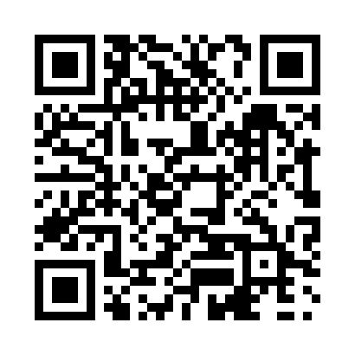
Prayer times for The Cedars, New Brunswick, Canada
Mon 1 Jul 2024 - Wed 31 Jul 2024
High Latitude Method: Angle Based Rule
Prayer Calculation Method: Islamic Society of North America
Asar Calculation Method: Hanafi

Date | Day | Fajr | Sunrise | Dhuhr | Asr | Maghrib | Isha
1 | Mon | 3:42 | 5:40 | 1:28 | 6:51 | 9:17 | 11:14
2 | Tue | 3:43 | 5:41 | 1:29 | 6:51 | 9:16 | 11:13
3 | Wed | 3:44 | 5:41 | 1:29 | 6:51 | 9:16 | 11:13
4 | Thu | 3:45 | 5:42 | 1:29 | 6:51 | 9:16 | 11:12
5 | Fri | 3:46 | 5:43 | 1:29 | 6:51 | 9:15 | 11:11
6 | Sat | 3:47 | 5:43 | 1:29 | 6:51 | 9:15 | 11:10
7 | Sun | 3:49 | 5:44 | 1:29 | 6:51 | 9:14 | 11:10
8 | Mon | 3:50 | 5:45 | 1:30 | 6:51 | 9:14 | 11:09
9 | Tue | 3:51 | 5:46 | 1:30 | 6:50 | 9:13 | 11:08
10 | Wed | 3:53 | 5:46 | 1:30 | 6:50 | 9:13 | 11:06
11 | Thu | 3:54 | 5:47 | 1:30 | 6:50 | 9:12 | 11:05
12 | Fri | 3:55 | 5:48 | 1:30 | 6:50 | 9:12 | 11:04
13 | Sat | 3:57 | 5:49 | 1:30 | 6:49 | 9:11 | 11:03
14 | Sun | 3:58 | 5:50 | 1:30 | 6:49 | 9:10 | 11:02
15 | Mon | 4:00 | 5:51 | 1:30 | 6:49 | 9:10 | 11:00
16 | Tue | 4:01 | 5:52 | 1:30 | 6:48 | 9:09 | 10:59
17 | Wed | 4:03 | 5:53 | 1:31 | 6:48 | 9:08 | 10:58
18 | Thu | 4:04 | 5:54 | 1:31 | 6:47 | 9:07 | 10:56
19 | Fri | 4:06 | 5:55 | 1:31 | 6:47 | 9:06 | 10:55
20 | Sat | 4:08 | 5:56 | 1:31 | 6:46 | 9:05 | 10:53
21 | Sun | 4:09 | 5:57 | 1:31 | 6:46 | 9:04 | 10:52
22 | Mon | 4:11 | 5:58 | 1:31 | 6:45 | 9:03 | 10:50
23 | Tue | 4:13 | 5:59 | 1:31 | 6:45 | 9:02 | 10:48
24 | Wed | 4:14 | 6:00 | 1:31 | 6:44 | 9:01 | 10:47
25 | Thu | 4:16 | 6:01 | 1:31 | 6:44 | 9:00 | 10:45
26 | Fri | 4:18 | 6:02 | 1:31 | 6:43 | 8:59 | 10:43
27 | Sat | 4:19 | 6:03 | 1:31 | 6:42 | 8:58 | 10:41
28 | Sun | 4:21 | 6:04 | 1:31 | 6:41 | 8:57 | 10:40
29 | Mon | 4:23 | 6:06 | 1:31 | 6:41 | 8:55 | 10:38
30 | Tue | 4:25 | 6:07 | 1:31 | 6:40 | 8:54 | 10:36
31 | Wed | 4:26 | 6:08 | 1:31 | 6:39 | 8:53 | 10:34
Prayer times provided by https://www.salahtimes.com

